Electronic Health Records (EHR)

Documentation Tutorial

Cleveland University –
Kansas City

Documenting a Patient Visit – Full New Note

Documenting a Patient Visit – Full New Note

A. Select a patient
1. Login to ChiroTouch through the ChiroTouch Launcher.

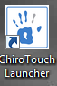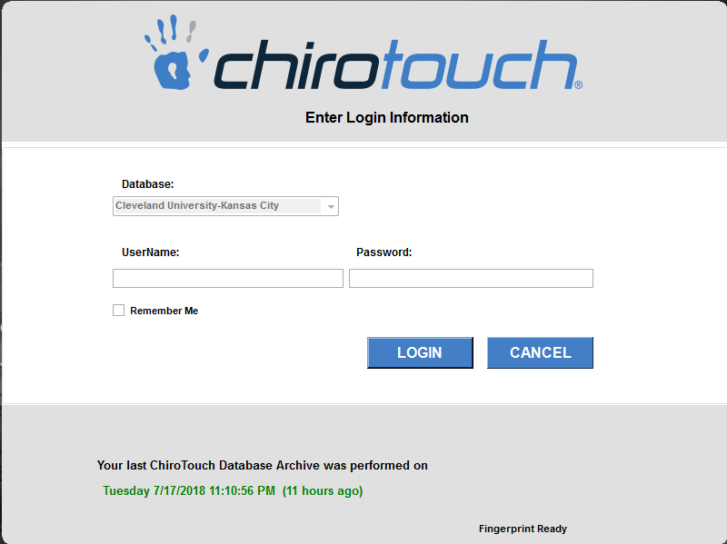

2. CT Launcher opens, click Colleges.
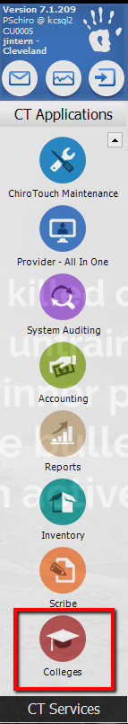
Scroll down to locate the Colleges Application and click on it.
B. Verify patient list on Dashboard and Status
1. Dashboard tab
2. Review Today’s Appointments to verify patient is scheduled and Status is checked in.
3. Click on Notes tab.

Note…..

For the patient information and status to reflect in the College Application, the patient must be on the Scheduler Application. See Introduction SOP for Scheduler overview.

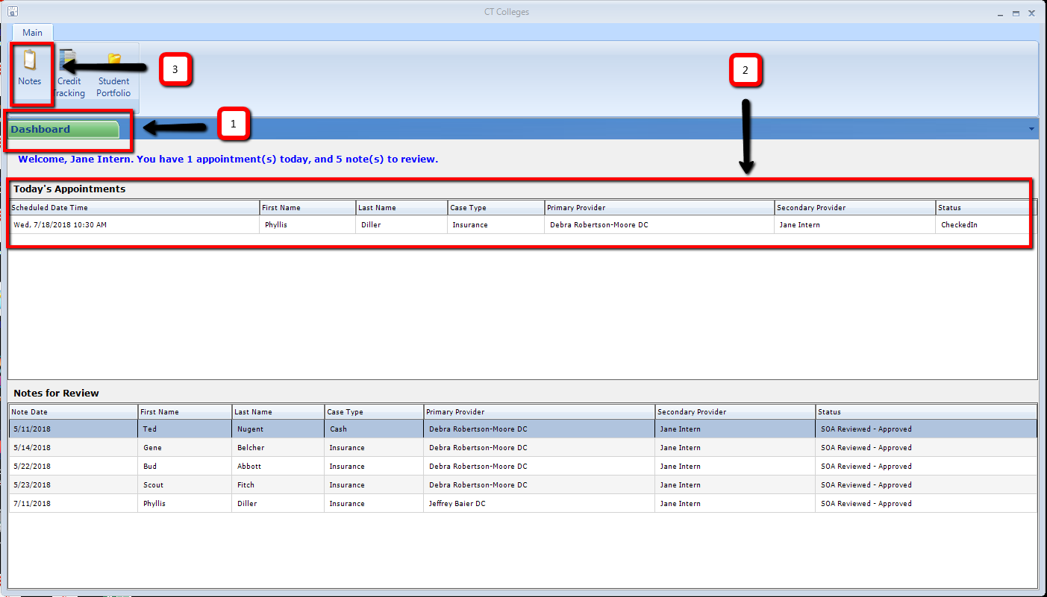
C. Note Tab Page
1. Notes tab indicates the user is in the Notes section of the College Application.
2. Appointment Search section allows the user to select from Today’s Patients or All Patients. Selecting All
Patients unlocks the date range dropdown boxes to select a specific date range. Click Search button to
update Search Results.
3. Search Results, lists patient information and current appointment status.
4. Click on New, listed under the Action Column to open a SOAP note for the patient.

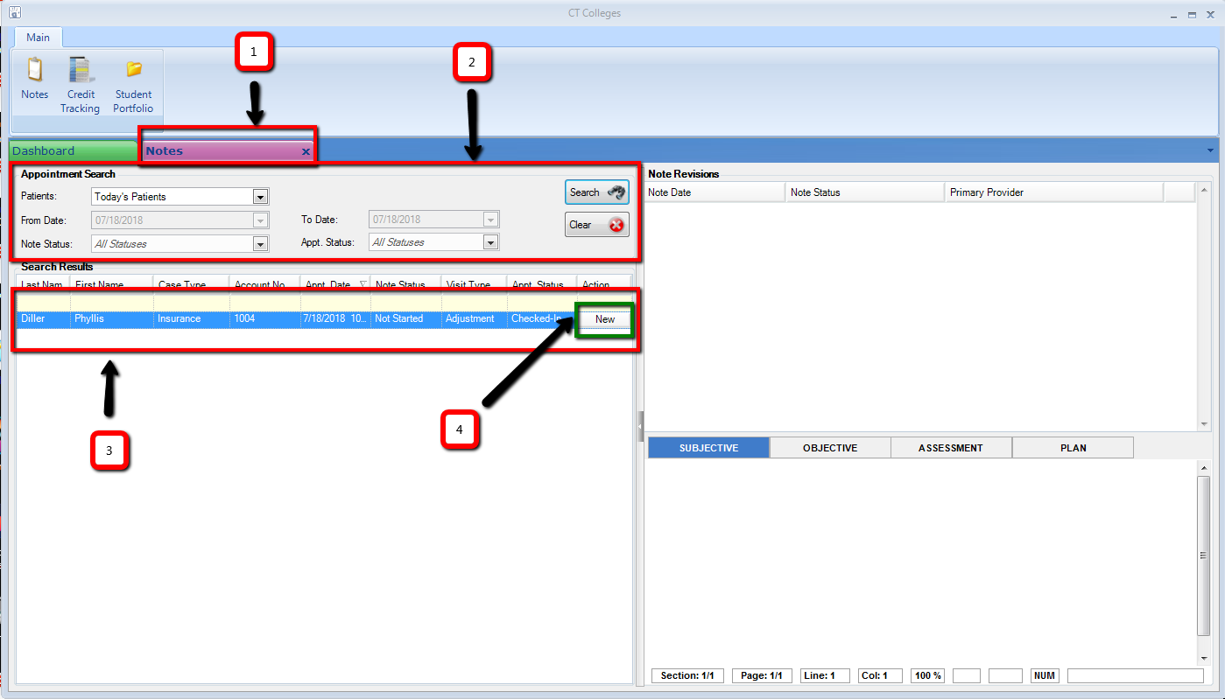

D. Subjective – Daily Note

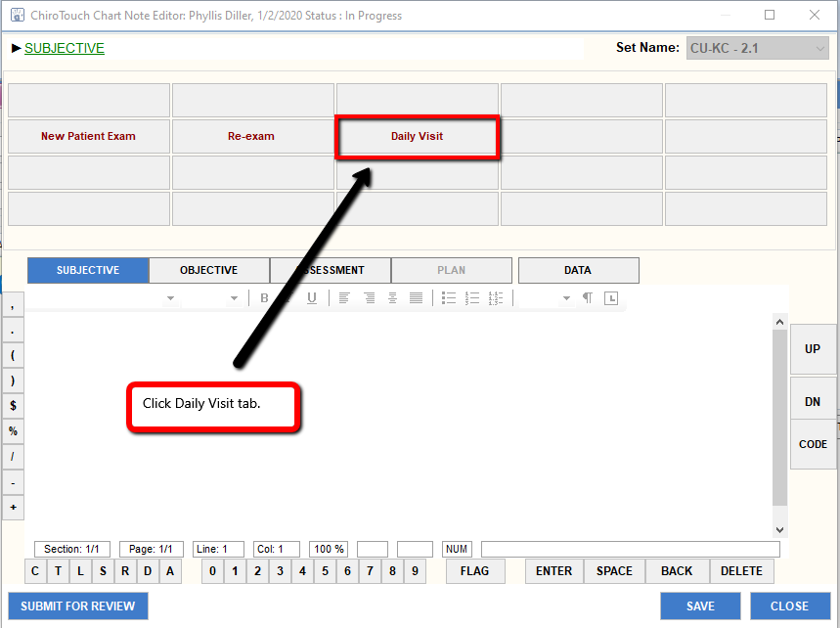

New screen opens to Text Macros (Text Macros are blue ink).

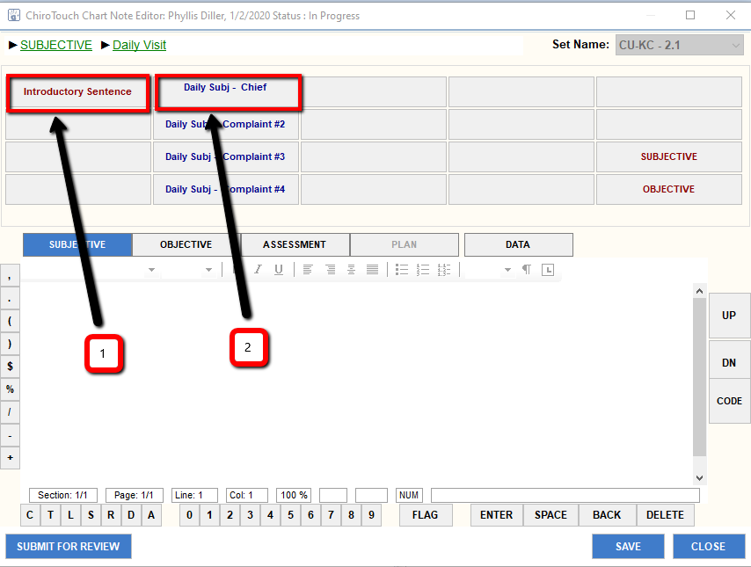
1. Introductory Sentence tab
2. Daily Subj – Chief tab

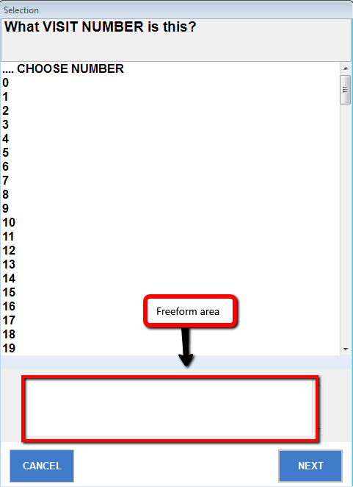
Clicking a text (blue) macro (like Daily Subj-Chief tab above), opens a new window that requires information. If more information is needed after answering the question, use the freeform section at the bottom of the pop-up window to add further information. Press next tab to move forward to the next item and continue thru the series of questions.

After completion of the questions, a narrative, based on the answers the user submitted appears in the freeform section of the Subjective section.

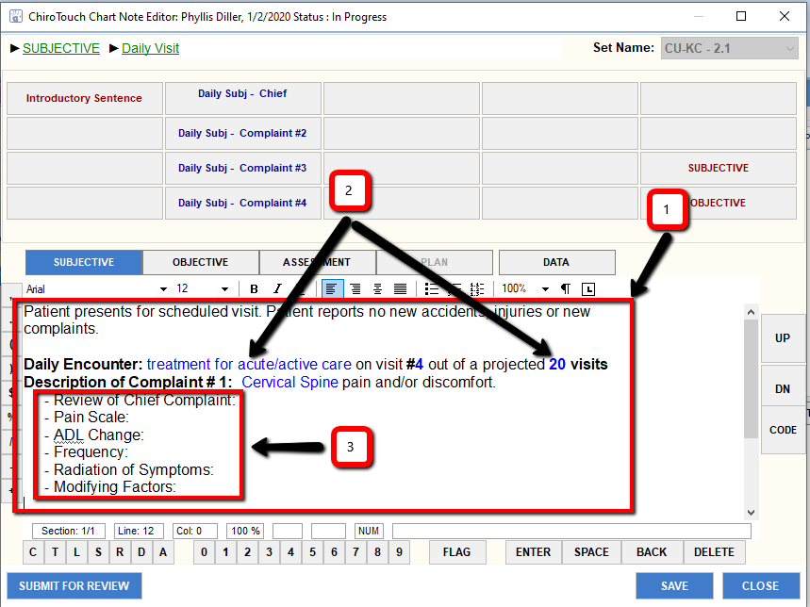
With multiple complaints, after history is completed on the initial/chief complaint, click Daily Subj – Complaint #2 to begin obtaining history on next complaint.
1. Narrative created from questions completed.
2. Blue text may be clicked on to open the question and edit answer(s) as needed.
3. Items completed by freeform.
E. Objective - Daily Note
1. Click Objective tab to open objective section.
2. Click Daily Objective Findings to access text menu.

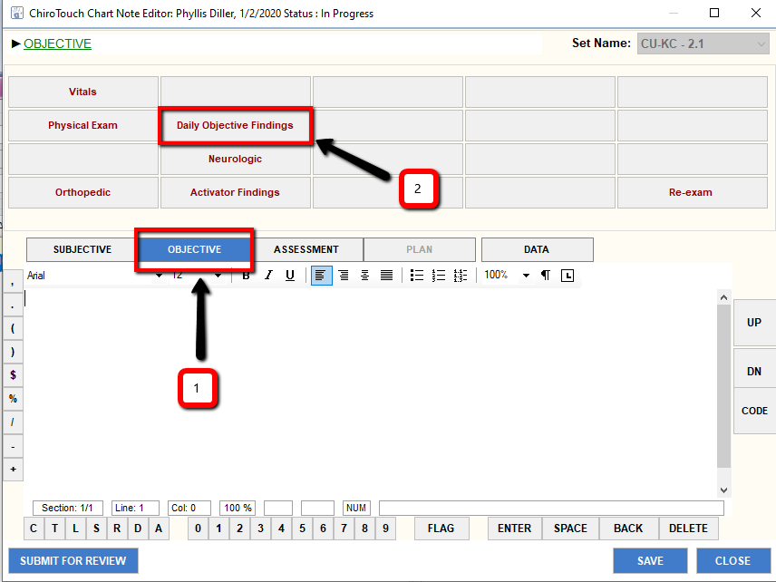

Click Daily Objective tab.
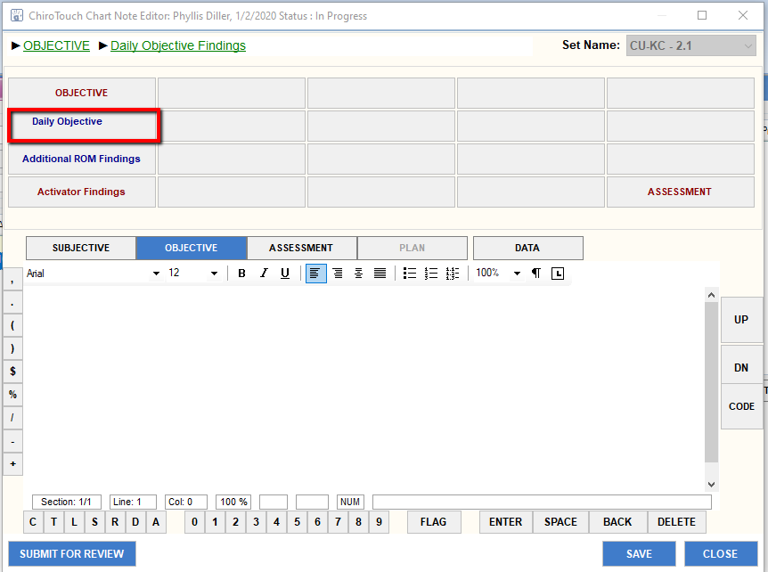

A list of prompts appears – complete the items based on examination in the freeform section of the Objective section.

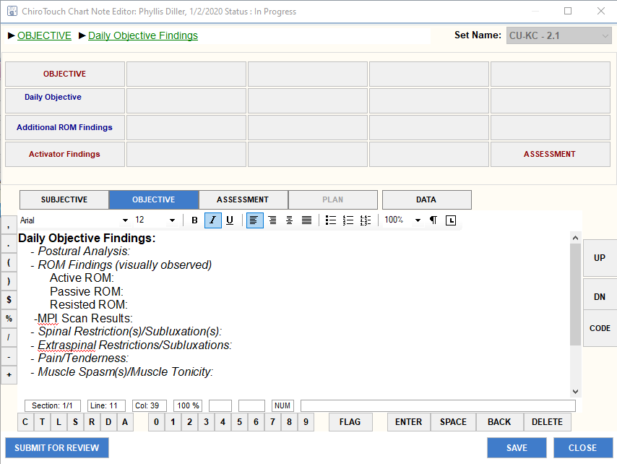

F. Assessment – Daily Note
Two paths are available for the user to enter diagnoses and charges into the daily note. Path 1 is entering the codes through or within the Provider All-in-One (PAIO) and Path 2 is entering the code through the CODE tab located on the right side of the SOAP note in the Colleges Application.
Both paths allow the user to complete diagnoses and codes, which upload into the Assessment portion of the note. During completion of new patient examination and re-examination, access and input of diagnoses and charges thru the PAIO are more efficient since the user is required to open and complete/update the care plan through the PAIO as part of that day’s note. Using the CODE function in the SOAP note of the College Application streamlines the process during an established treatment care plan for daily visits by removing the need to open the PAIO since the approved diagnoses/charges are uploaded directly through the note.
As ChiroTouch continues adding further enhancements to the College Application portion of the program, a thorough understanding of these functions is necessary.

Path 1:
Before moving to the Assessment section, either minimize the SOAP window or click SAVE tab to save the note and X out of the window. Then, click on the Provider All-in-One application to add/update Diagnoses and Charges for the visit:
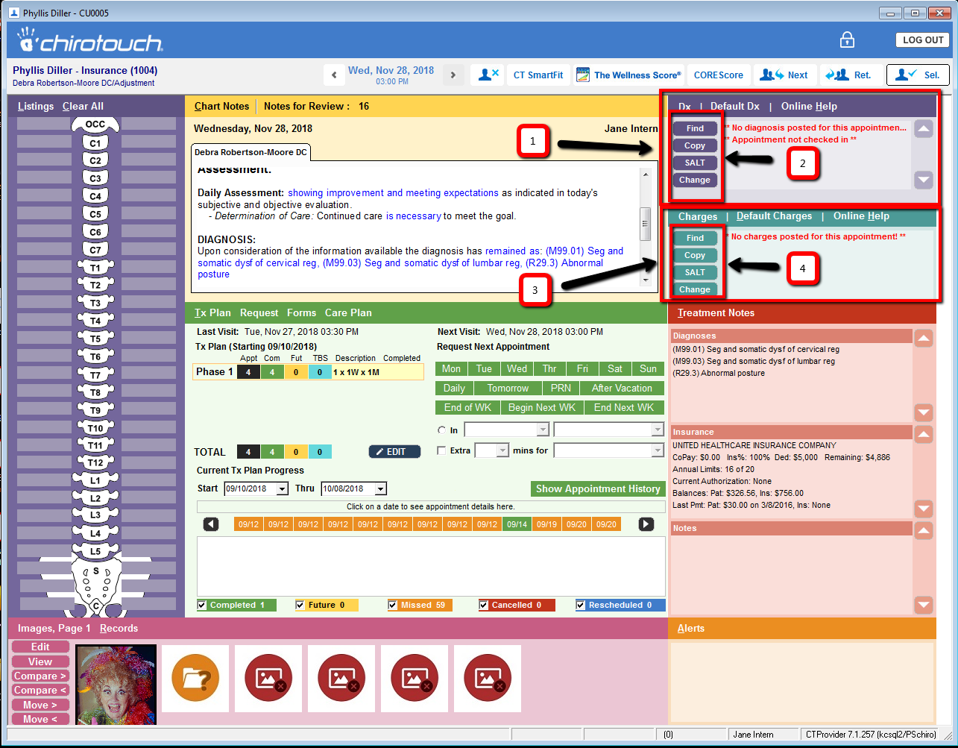

1. Dx(Diagnosis(es) box)
2. Click the appropriate box to select the diagnosis/diagnoses for the visit:
Find – to search list of available diagnoses
Copy – to copy from a previous note
SALT – (Same As Last Treatment) exact copy of diagnosis/diagnoses used on last note
Change – to select a different diagnosis from the favorites tabs (to be created in the near
future)
3. Charges box

4. Click the appropriate box to select the charge(s) for the visit:
Find – to search list of available charges
Copy – to copy from a previous note
SALT – (Same As Last Treatment) exact copy of charge(s) used on last note
Change – to select a different charge(s) from the favorites tabs (to be created in the near
future)

Minimize or X out of the PAIO, reopen the College Application, open the current note and click Assessment tab to open Assessment section.

--- OR ---

Path 2:
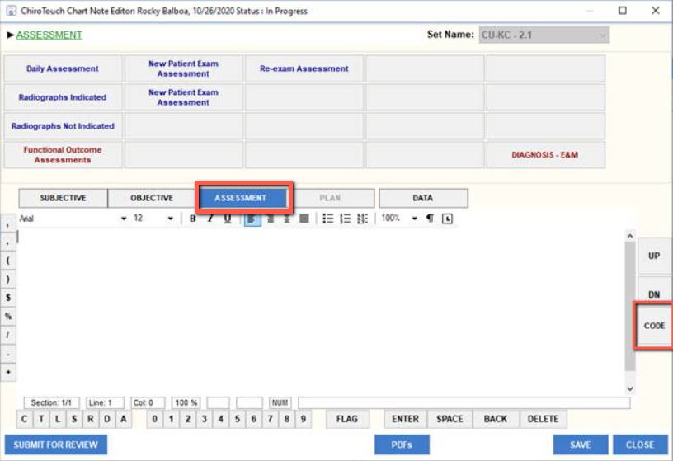
1. Click Assessment tab to open Assessment section.
2. Click CODE tab to open the Chart Note Coding window for selection of Billing and Charges codes.
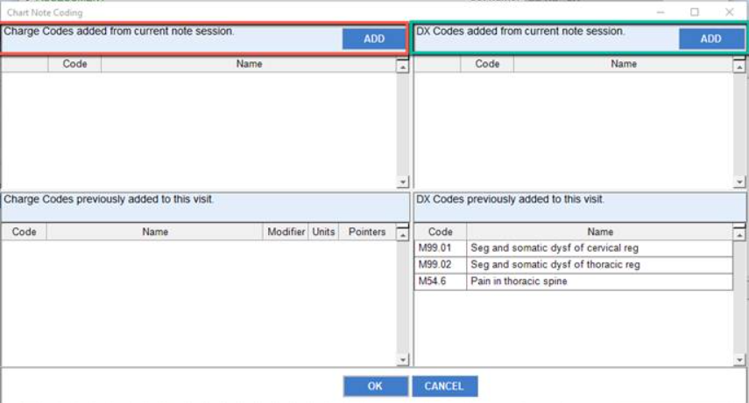
3. Click the ADD tab in the DX Codes box (green circled box) to open the available list of diagnosis
(ICD-10) codes to select from.
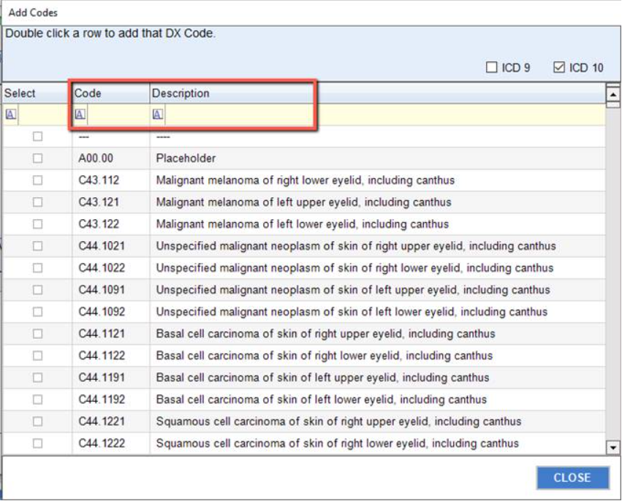
4. In the yellow box (circled in pink), enter the code number under Code or word description under
Description.
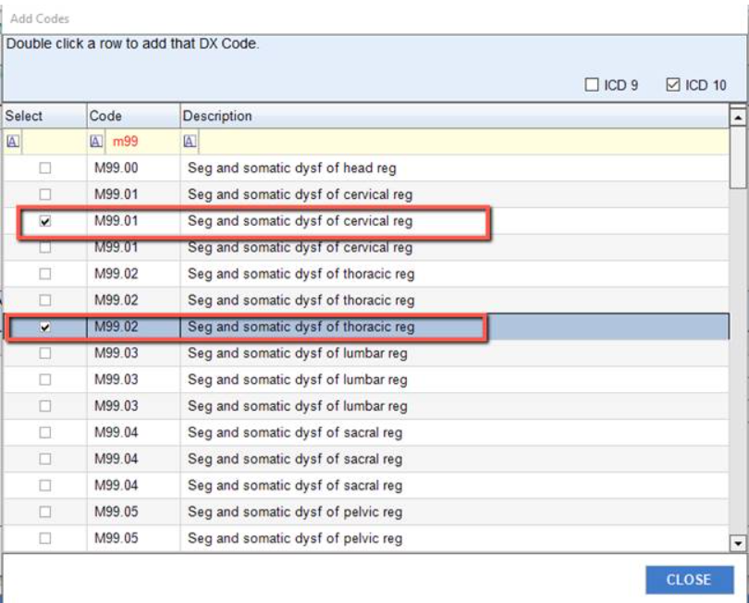
5. Locate the specific code and double click the line item (or click the box under the Select Column) to
add it to the Chart Note Coding Box. Multiple codes may be selected. Click CLOSE.

6. Click the ADD tab in the Charge Codes box to open the available list of Charge (CPT) codes to select,
then repeat steps 4 and 5. When finished, click CLOSE tab to exit the CODE window.

Review the Chart Note Coding Box appearance after completion of steps 3-6:
Note the Remove tabs next to each added code, in the event it is incorrect and needs to be
removed.
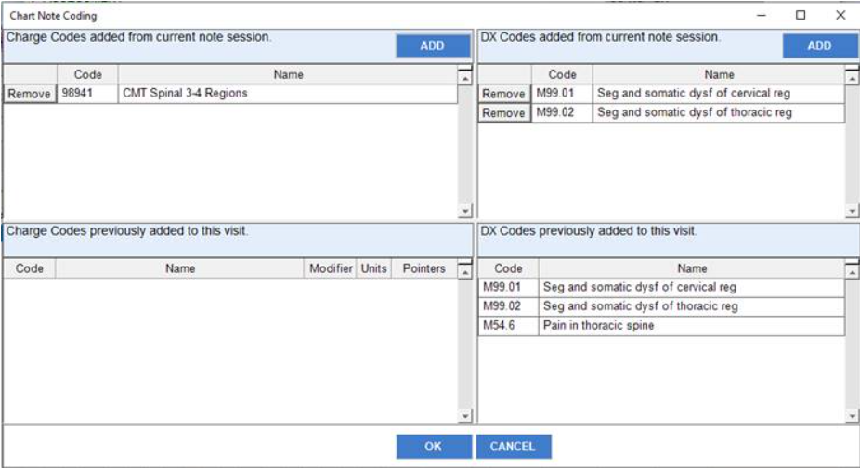

8. Click OK tab to close the window and return to Assessment.

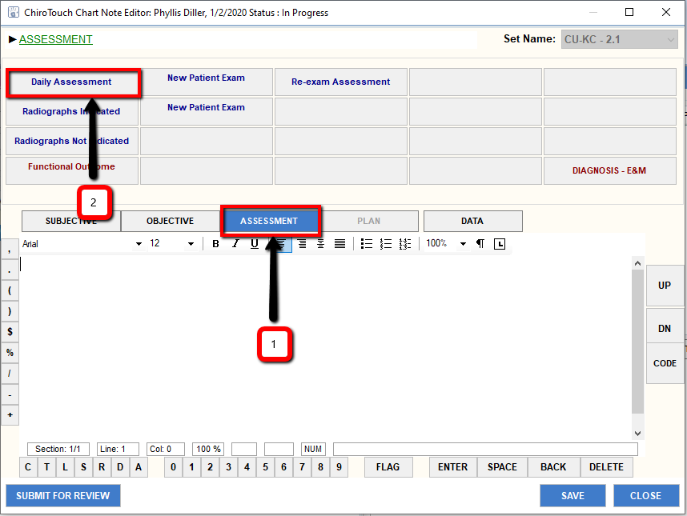
1. Verify Assessment tab is hi-lighted – identifies the user is currently in Assessment section.
2. Click Daily Assessment – a list of prompts appears – complete the items based on examination in the
freeform section of the Objective section.
a. Prompts are completed freeform – based on patient’s subjective/objective findings.
b. With completion of the S-O-A portion of the note, click SAVE tab. Clicking SAVE tab saves and closes
the note, creating a new line item with an EDIT tab in the Note Section of the Colleges
Application. This action pushes the selected diagnoses and charges into the Provider-All-In-One
(PAIO) which is required for billing purposes.
c. Click the EDIT button to re-open the note.
d. Click the Submit for Review tab.

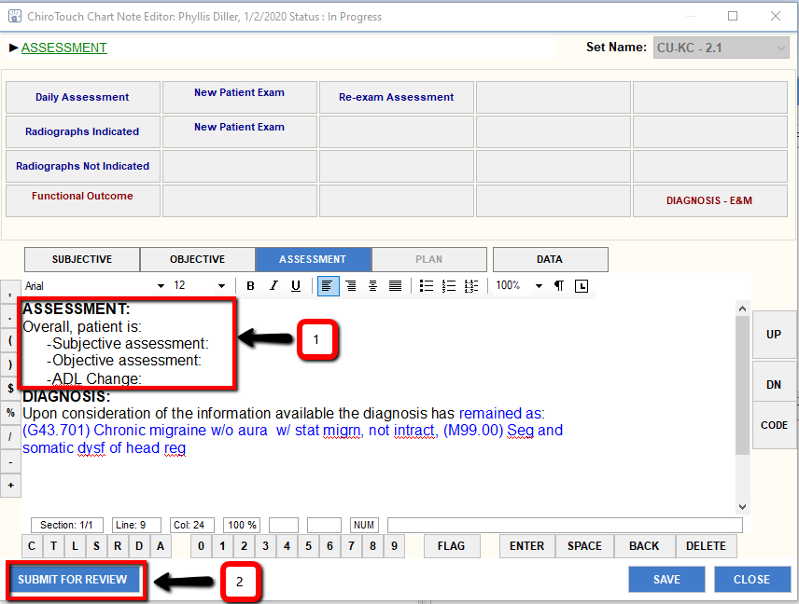

Once, Submit for Review tab has been clicked, a new line entry in the under the Notes tab, Note Revisions section, in the College Application appears and is ready for a Primary Provider to Edit.
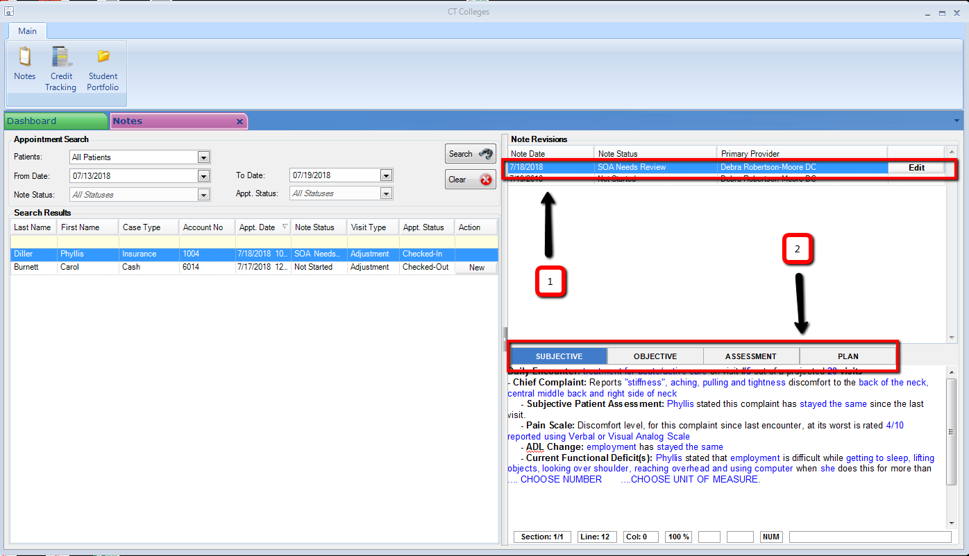

1. Line entry showing note status (SOA Needs Review).
2. Section that allows for review only (edit function is completed via Edit button under Note Revisions
section).

Primary Provider reviews the note.
1. With changes needed, Primary Provider documents the required change(s) at the bottom of the
appropriate section(s);
2. Click Changes Needed. This forwards the changes needed version into the College Application Note
Revisions section for the intern to review/edit.
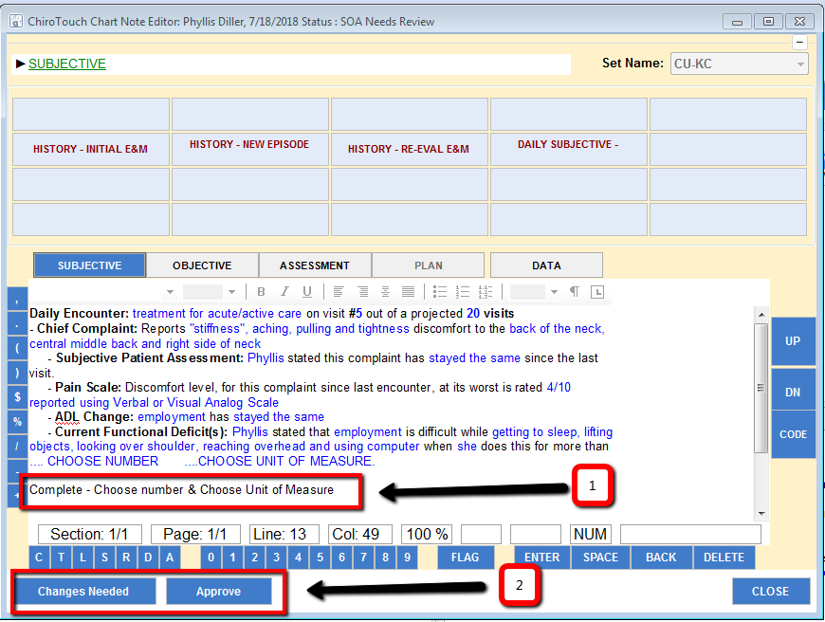

1a. Click SOA Needs Review line to view: 1b. requested changes from Primary Provider.
2. Click Edit tab on SOA Reviewed – Changes Needed line to open the note and complete note
correction(s).
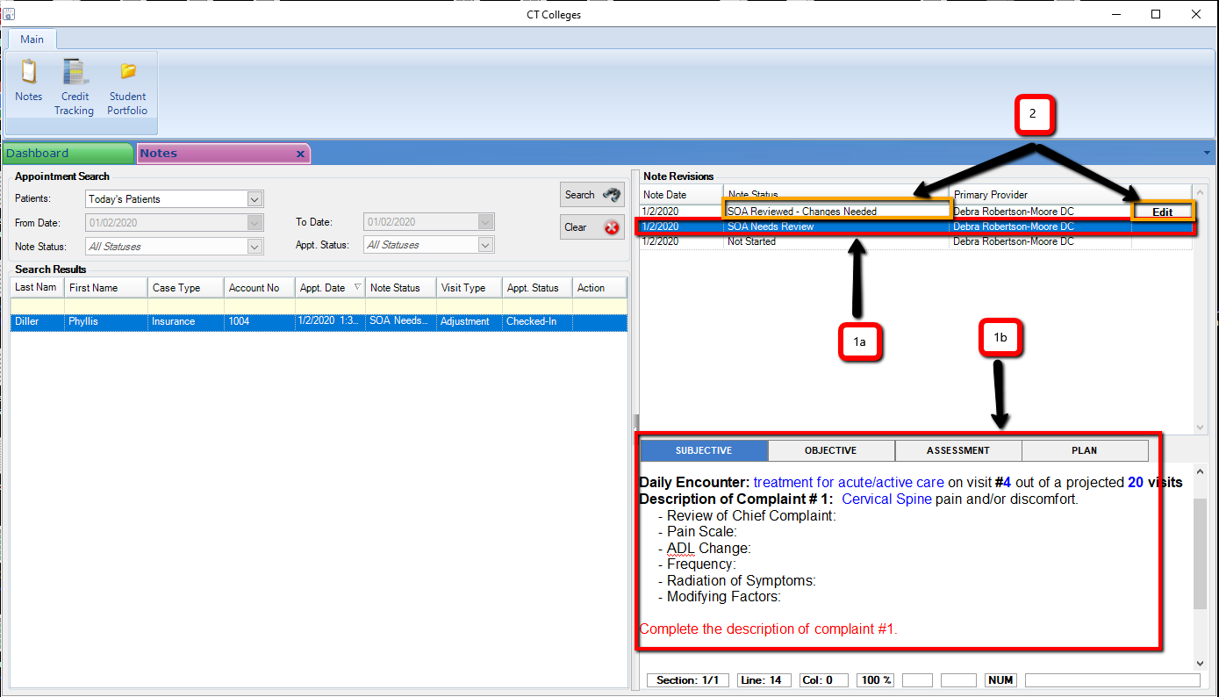
With changes completed, click Submit for Review tab.

G. Plan – Daily Note
Primary Provider completes the review process again. With approval, Secondary Provider, clicks Edit and
1. Click on Plan tab.
2. Click on Today’s Treatment tab.
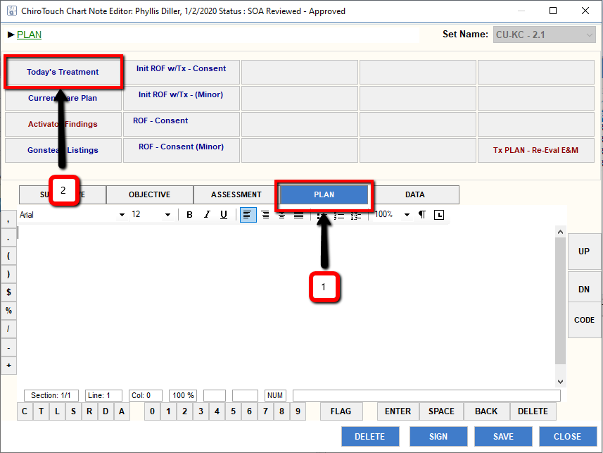
Secondary Provider completes questions, documents Primary treatment specifics, Post MPI Scan and Response to care prompts. Secondary Provider completes questions – documenting treatment specifics, treats patient and completes response to care.
Once treatment and note is complete, secondary provider clicks Sign tab to complete the note and upload signature into the completed note.
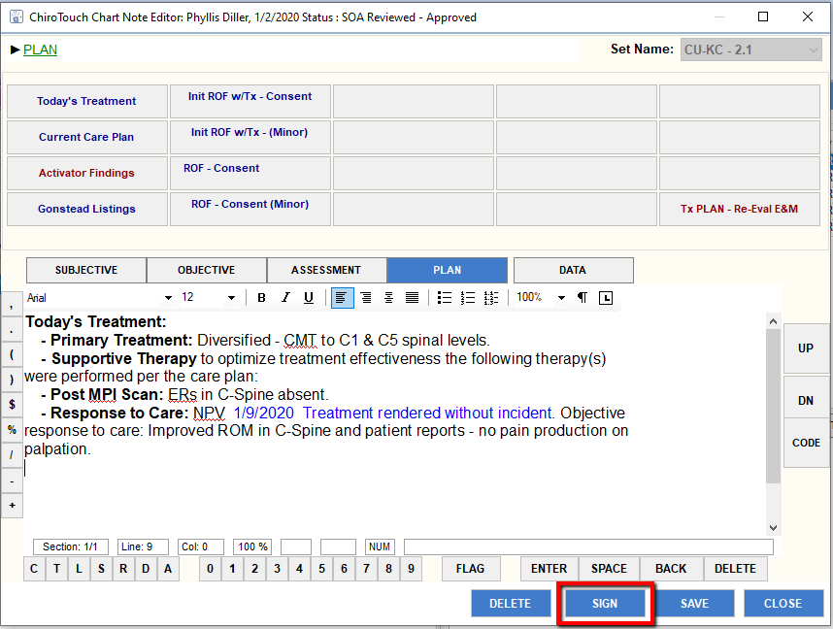
Pop-up window appears for signature:
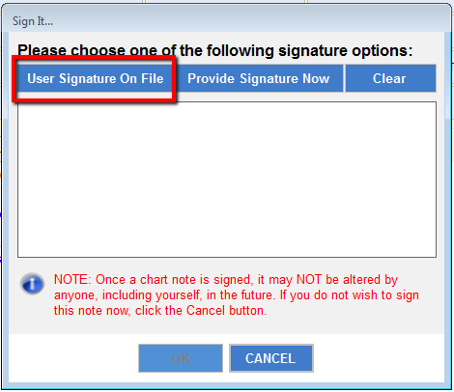

Click User Signature On File tab.

Verify Login window opens and Secondary Provider enters password to verify login.
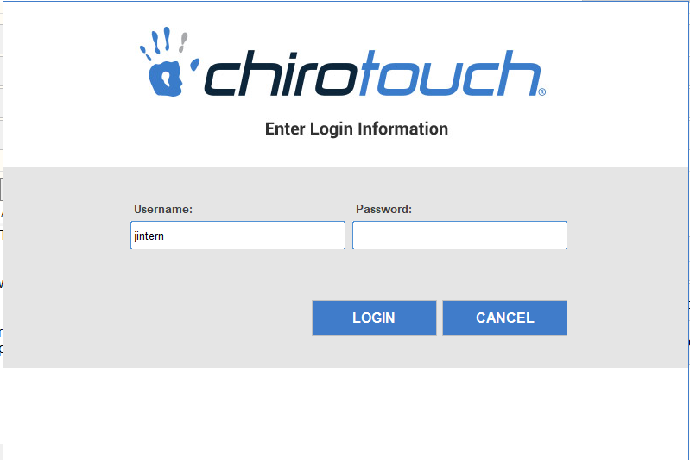

With verification of login, uploaded signature appears and Secondary Provider then clicks Ok to upload signature which completes the note.

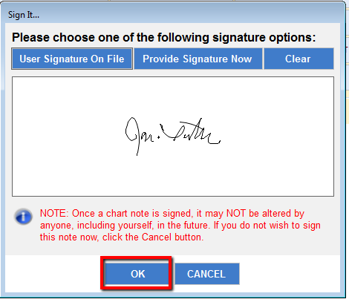
In addition to working in the College Application, all Providers (both Primary and Secondary) will work in the Provider All-in-One application (PAIO). Additions and/or changes to the patient’s diagnoses and treatments are completed in the PAIO, prior to completion of the note in the college application – or before Primary Provider completes final review and completion of the note. Note….. Within the College Application there is NO access to add/change diagnosis/treatment codes. (See pages 16-19)
After Secondary Provider has completed the note, the note requires a final review/signature by the Primary Provider and reflects in the Note Revisions section:
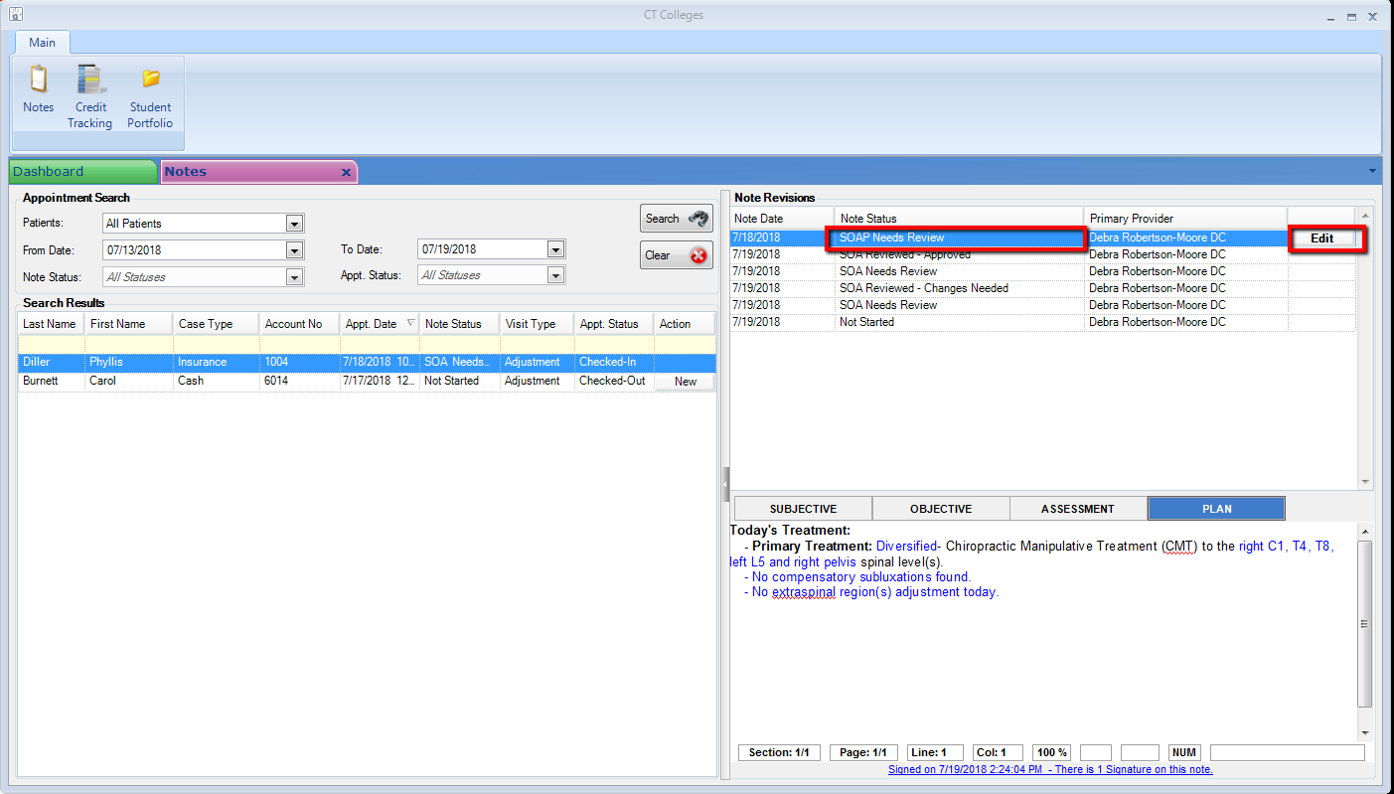
Note…. Through this process, both the Secondary and Primary Providers can BOTH work in the College Application through the Secondary Provider’s account/login. For the final note approval (Primary Provider Signature), the Primary Provider is required to login into the CT program as the user and complete the note through the College Application.

H. Primary Provider – Signature (Completion of Note)
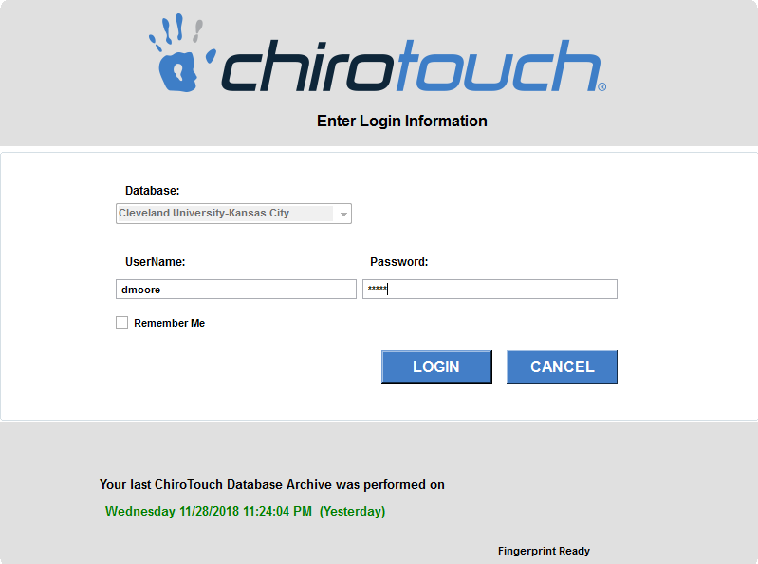 Primary Provider signs into
ChiroTouch.
Next, click Colleges Application:
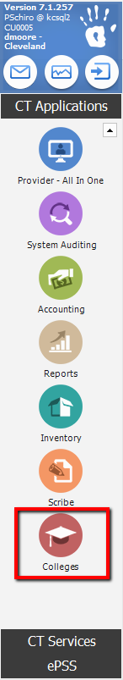

Click Notes:
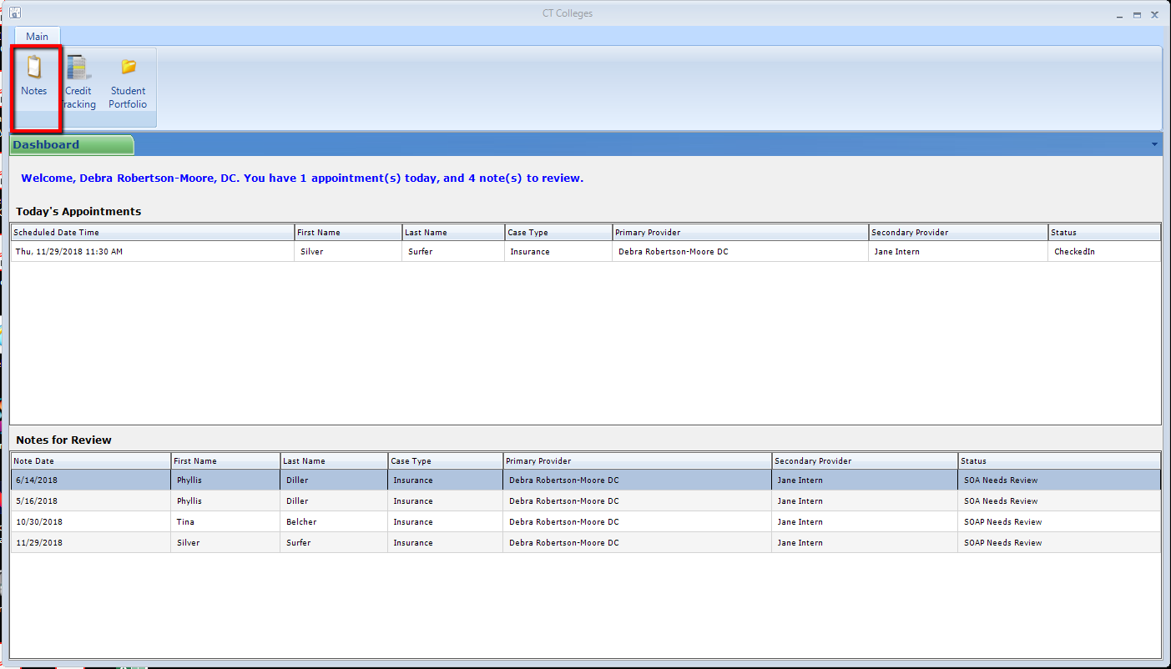

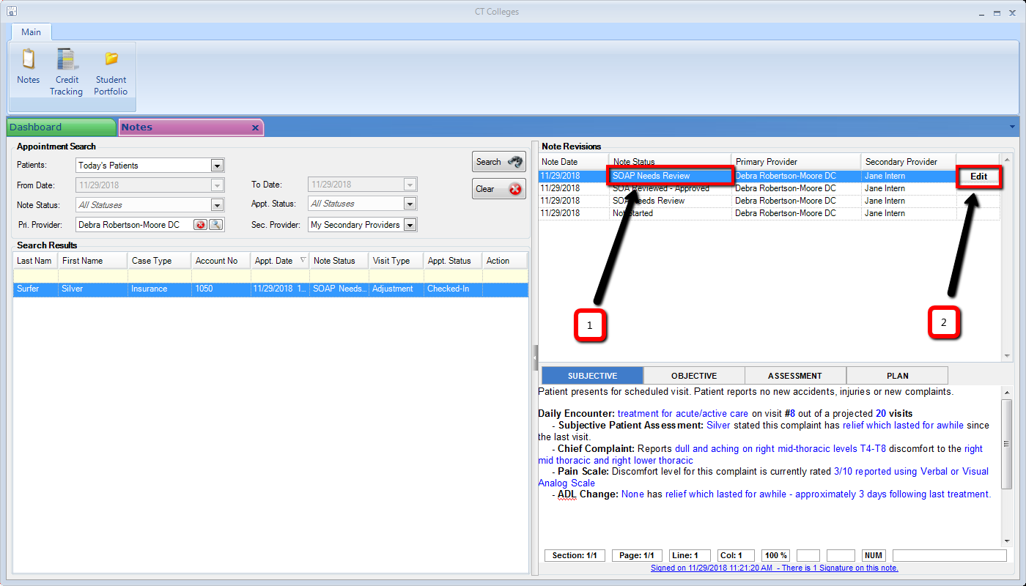
1. Locate Note Status SOAP Needs Review
2. Click Edit to open the Note
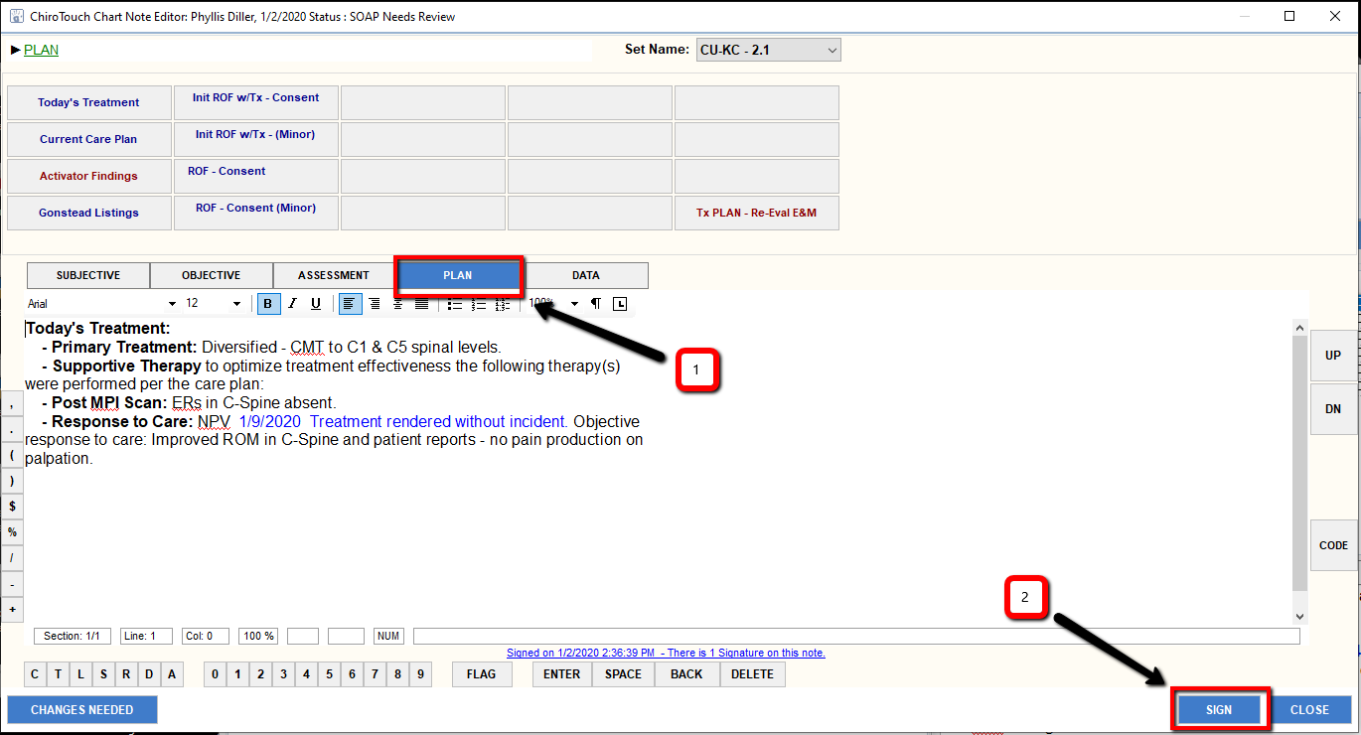
1. Click Plan tab, review Plan section and verify ICD-10 codes/charges are marked on service slip
2. Click Sign, which opens a new popup window
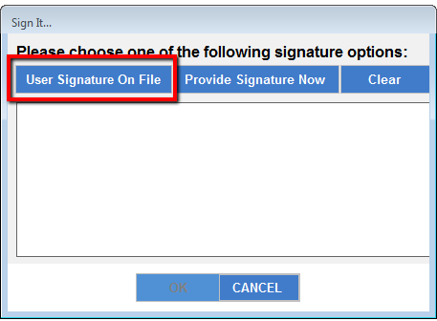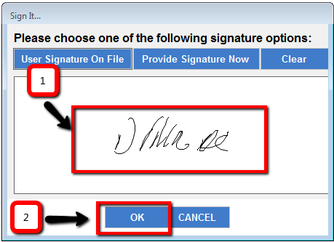
Click User Signature on File 1. Review signature
2. Click Ok tab to accept signature and complete the note.

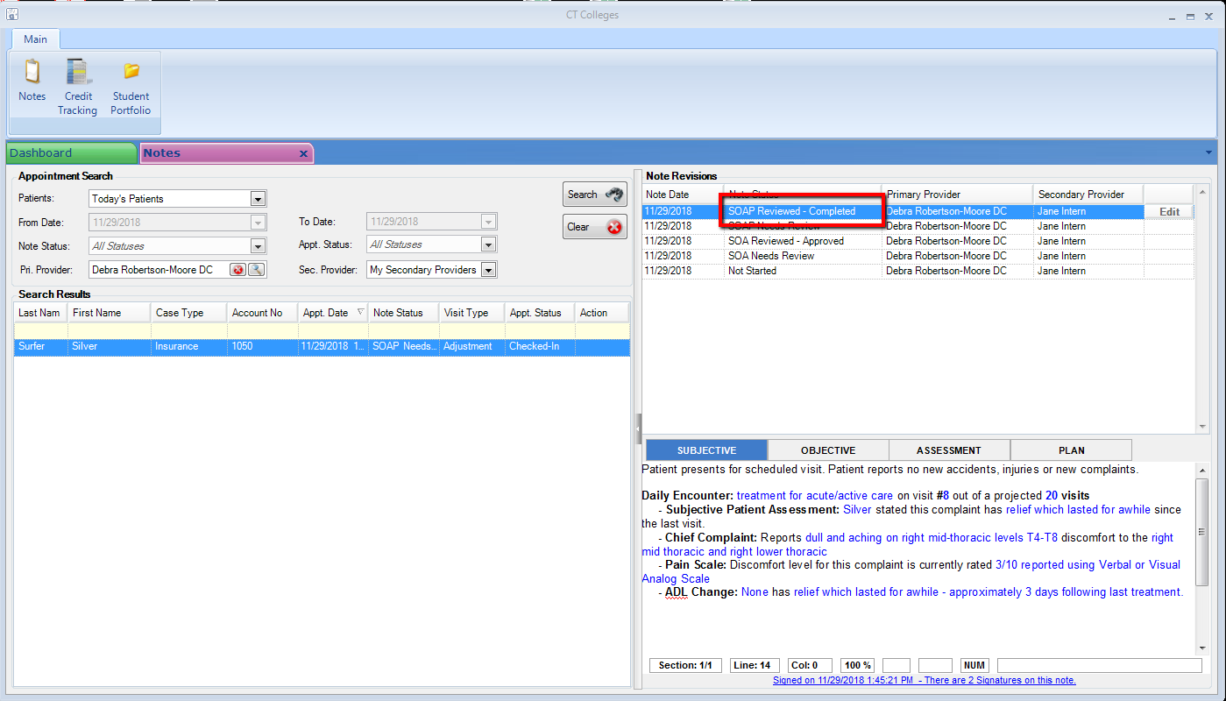
New line appears with the Note Status of SOAP Reviewed - Completed

