Electronic Health Records (EHR)

Documentation Tutorial

Cleveland University –
Kansas City

Documenting a Patient Visit – New Patient Examination

Documenting a Patient Visit – New Patient Examination

A. Patient Intake
Patient calls Front Desk to schedule new patient examination appointment; or, Intern speaks to Front Desk Staff, providing appointment day/time, Patient Name, DOB, phone number, email address, Primary and Secondary Providers, Intern number.
Front Desk emails CT intake information link to Patient. Patient completes intake paperwork and presents to CUKC Clinic for New Patient Examination. Front Desk uploads the intake information into the patient file. Intern escorts Patient to examination room, and then meets with Primary Provider to review the intake information. After completion of intake information review, Primary Provider meets the patient and the Intern is ready to begin the S portion of the new patient examination.

Through the CT Applications, click on Colleges to open the College Application.

B. Subjective (S)
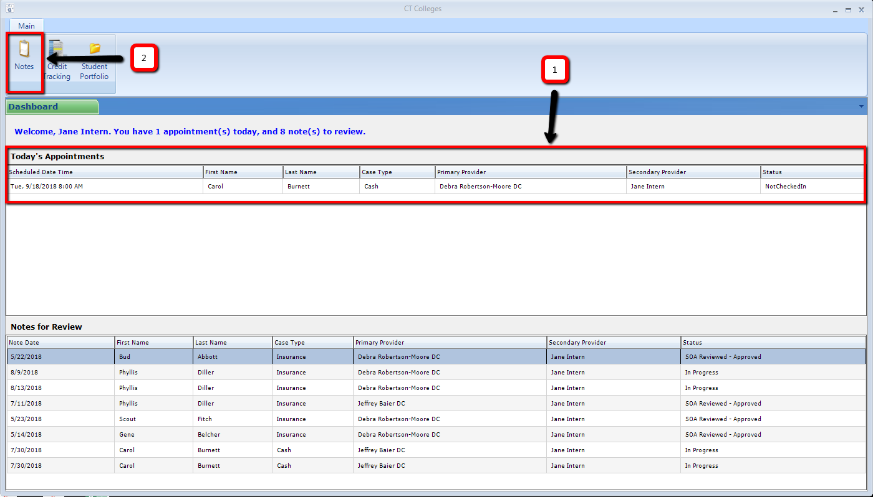
1. Verify scheduled patient(s) listed under Today’s Appointments.
2. Click on Notes icon.

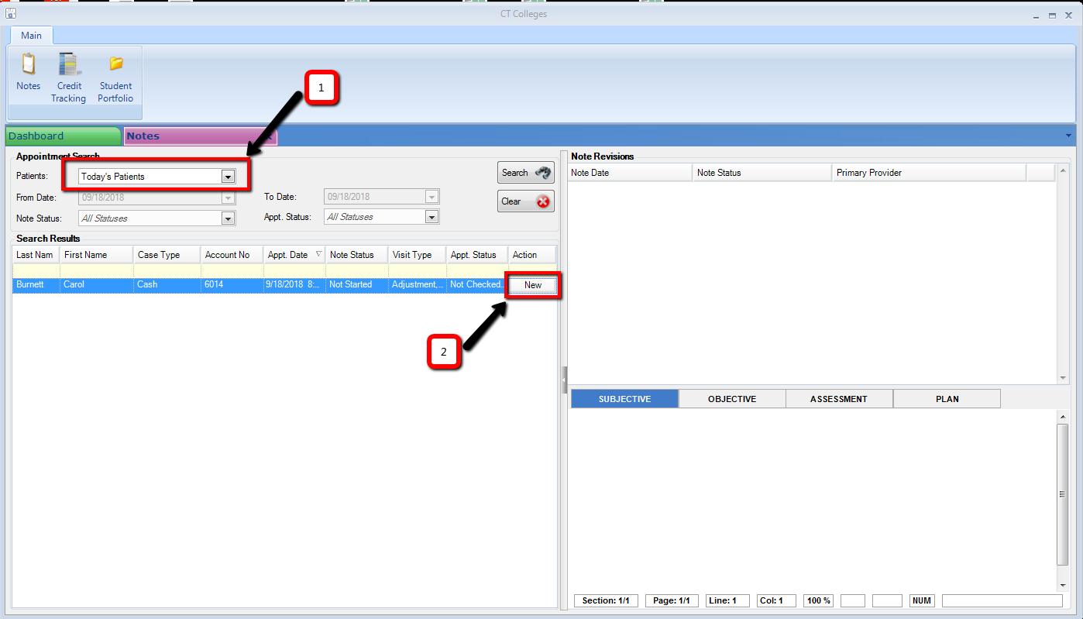
1. Verify Appointment Search area is set to Today’s Patients.
2. Locate new patient and click on New tab to open the patient’s SOAP note.

New screen, the SOAP note, opens:
Click New Patient Exam
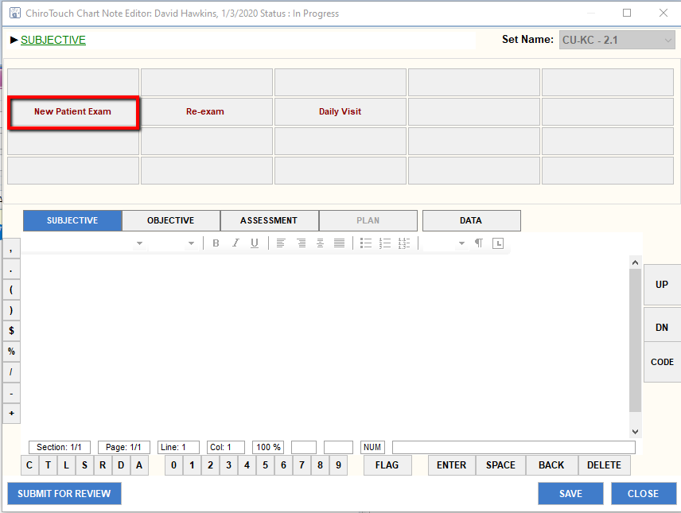

Click Introductory Sentence
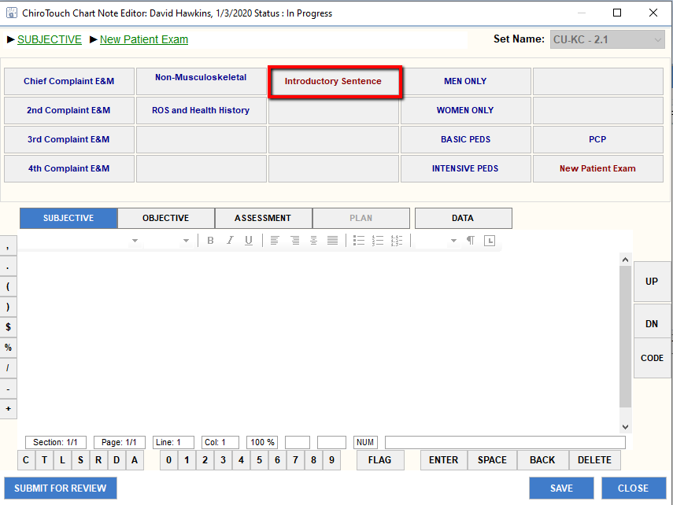

Click the appropriate item(s) that reflects purpose for today’s appointment
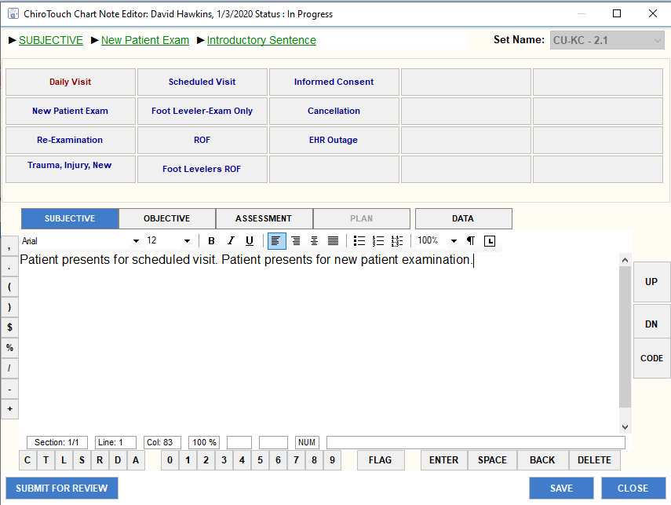

Click ROS and Health History tab:
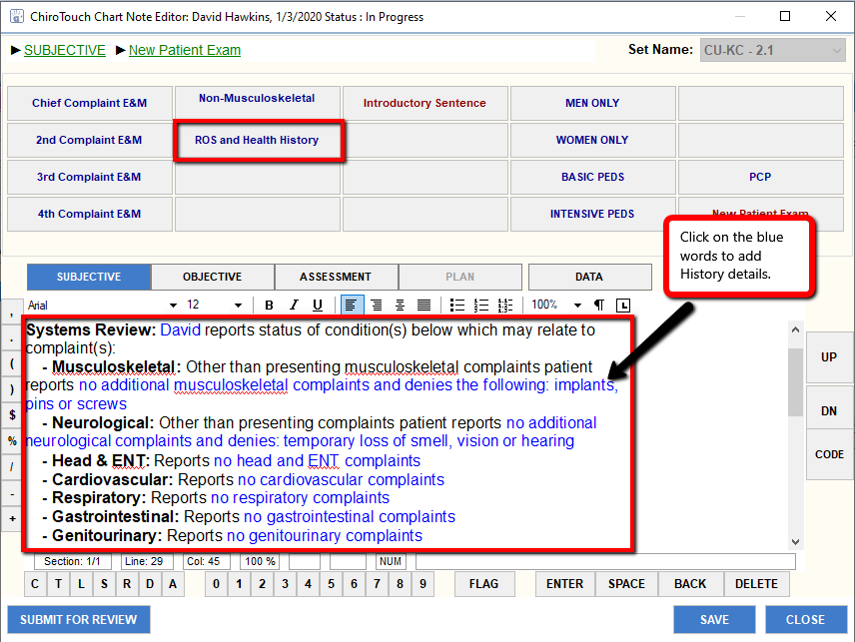
Freeform input in ROS and Health History information determined by amount of history the patient adds to the intake form. This section requires review for every new patient.

Next, begin history on Chief Complaint:
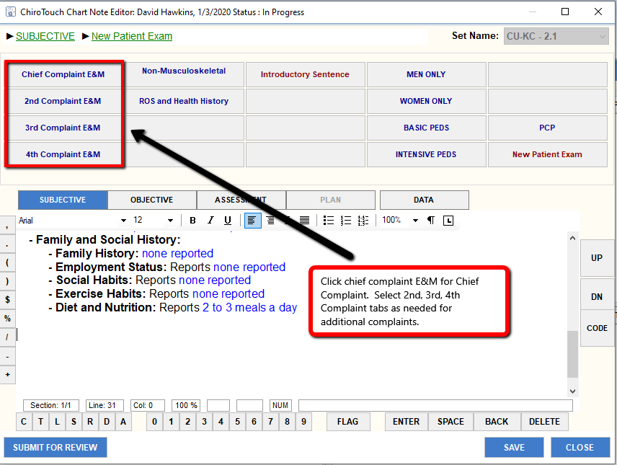

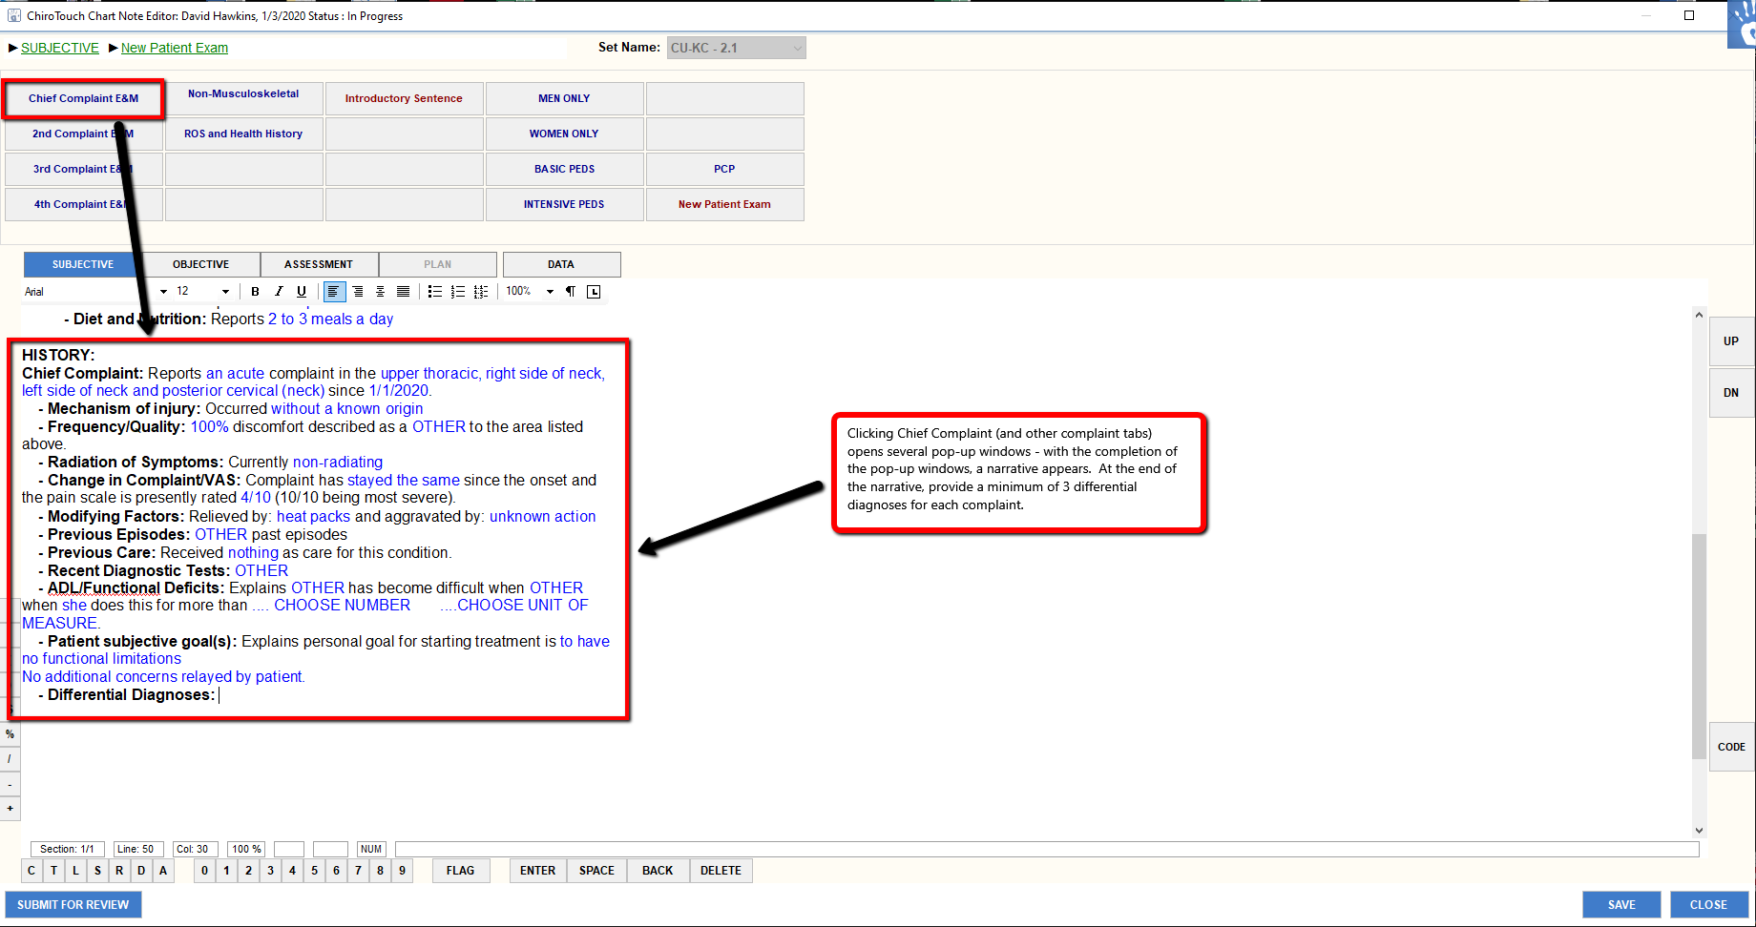

Outcome assessment forms are completed on hardcopy forms. Primary Provider signs the form with review of History and Secondary Provider gives the form to the Front Desk Personnel at the end of the appointment, who will then scan the document(s) into the Patient’s EHR file.

C. Objective (O)
1. Click on Objective Tab to move into objective section of the SOAP note.
2. Click on Vitals Tab
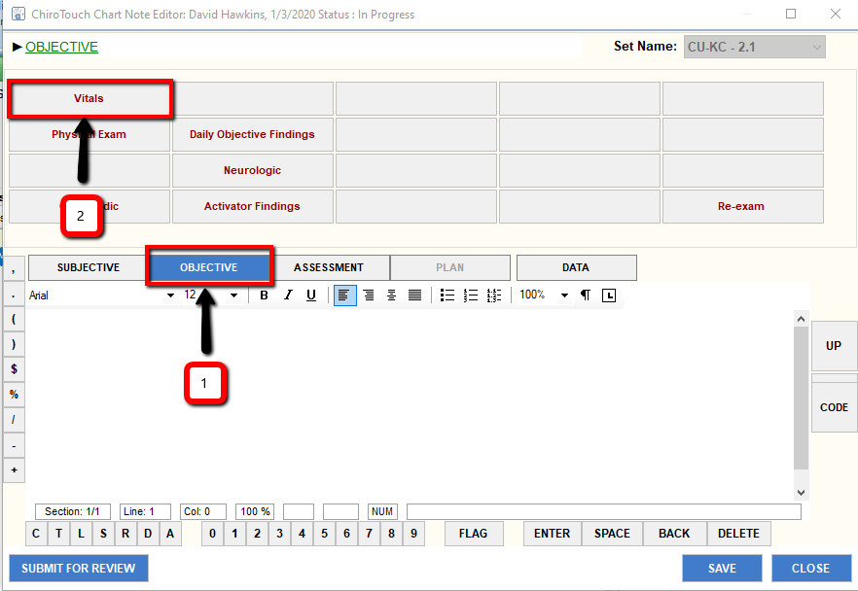

Click on HT-WT-Pulse-BP-Resp-Tem Tab
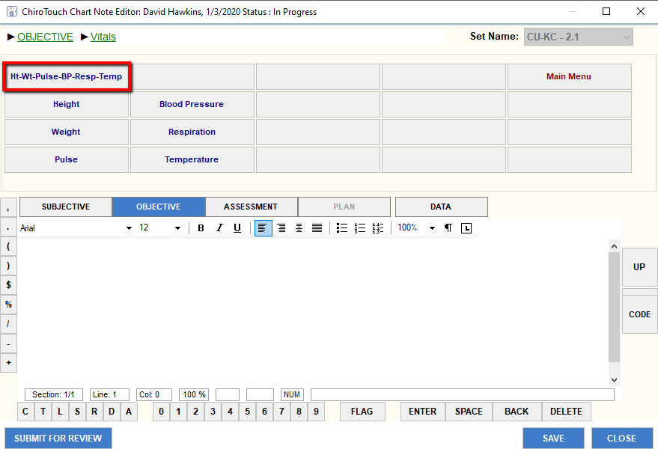

A new window opens:

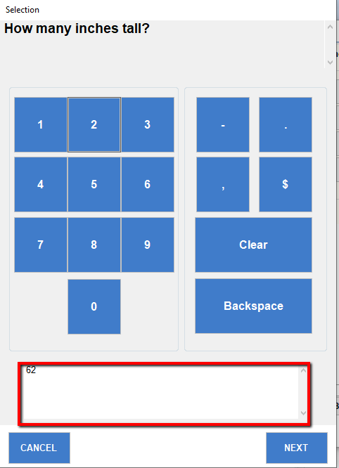
Perform vitals and enter the information in the window that is open, then click Next to proceed to the next procedure in the list. Note: the box at the bottom of window reflects the information entered for that particular window AND allows the provider to freeform additional information as needed.

Objective Page w/Vitals:
1. Narrative from addition of vitals examination
2. Blue text can be clicked on to edit loaded information; additional text
can be added in the Black text by placing courser in area the user
wants to freeform additional information.
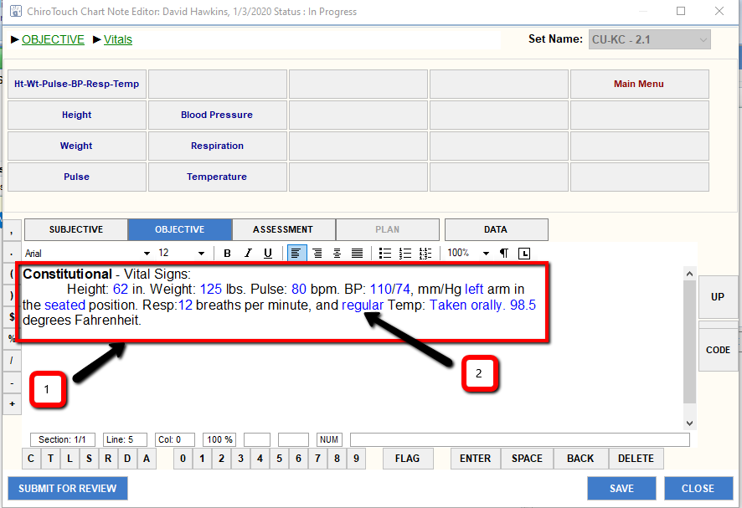

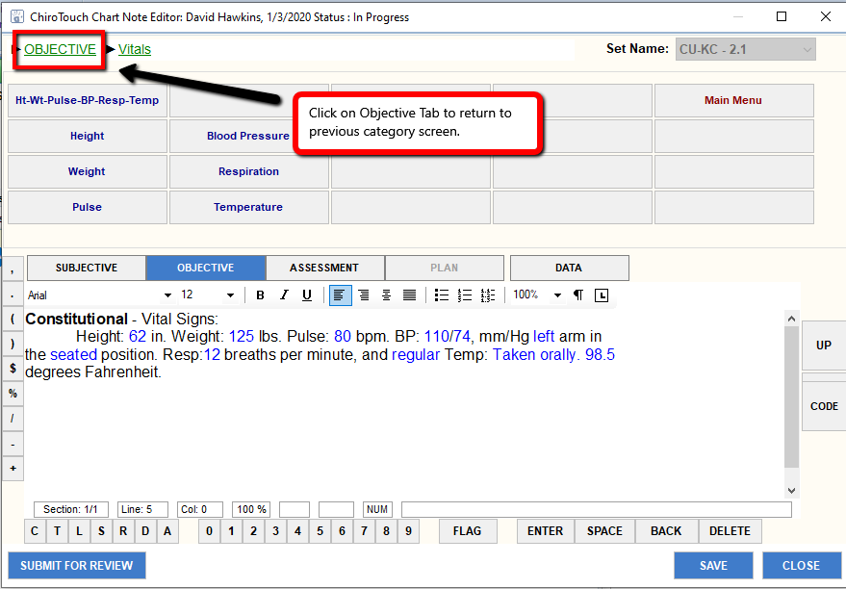

Physical Exam portion:
Click Physical Exam Tab
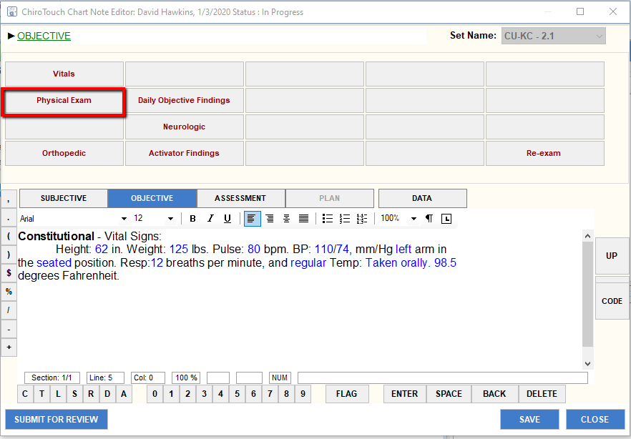

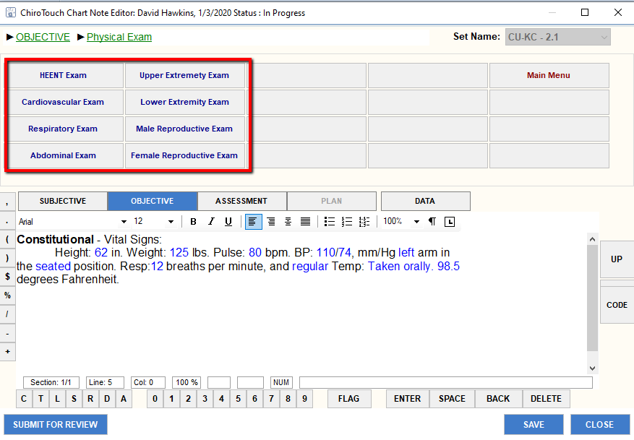
Click each of the tabs (as appropriate), examine each listed item and document
presence of abnormal findings.

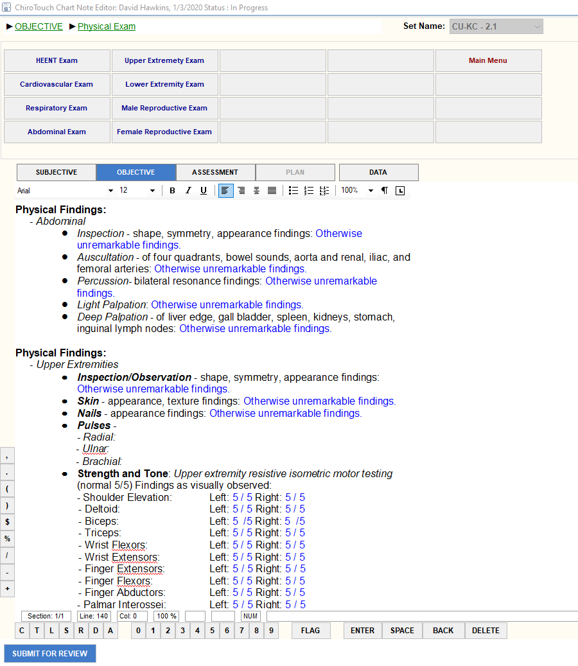
Click Objective Tab in breadcrumb at the top of the SOAP note to return to previous category screen.
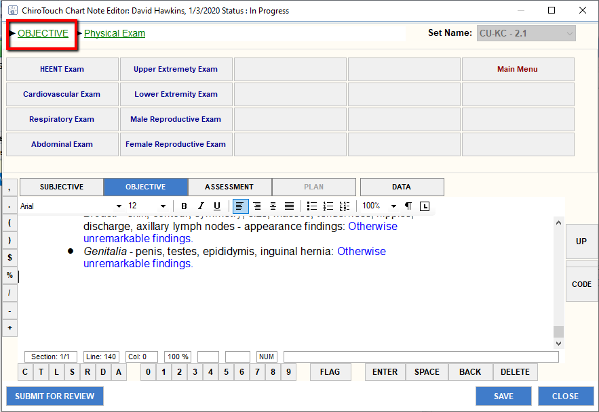

Click Neurologic Tab
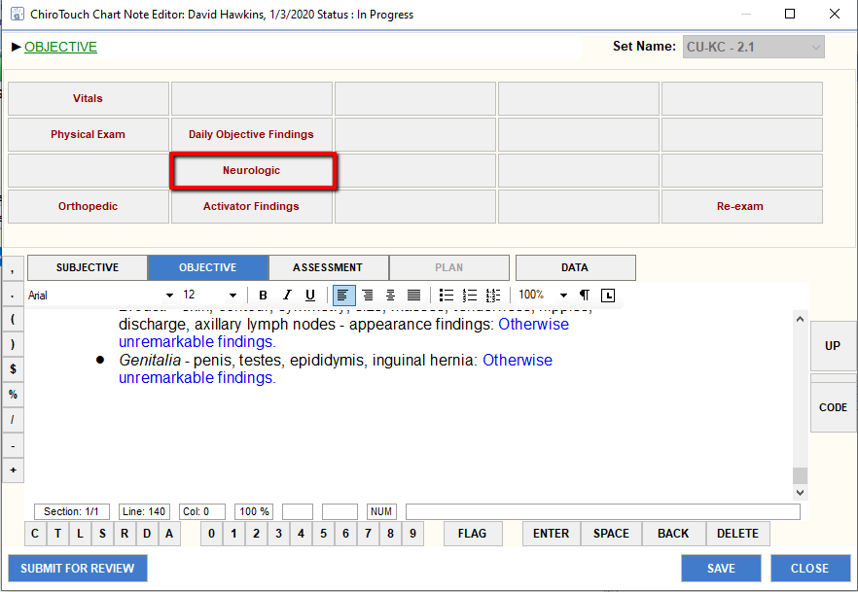

1. Click on Master Neuro U/E & L/E – list populates into the Objective
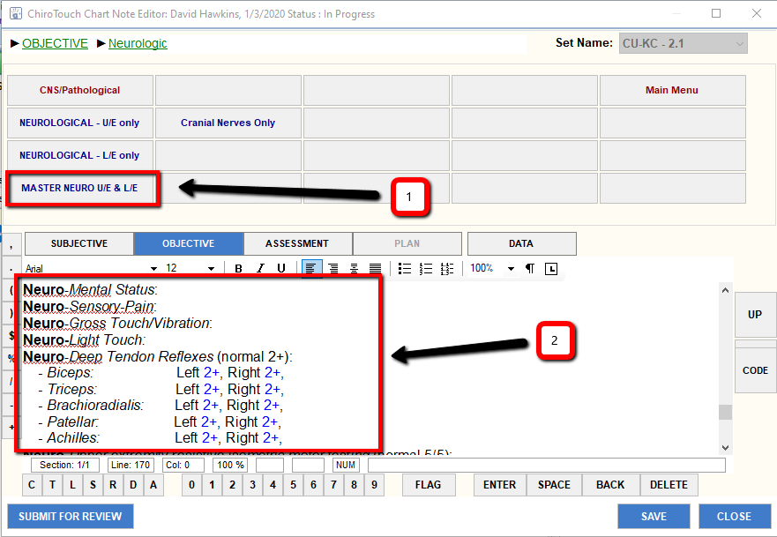
2. Once the Neurologic Exam populates into the Objective section, perform listed tests and document all results that differ from items listed in the narrative. To change an item, click on the blue lettering.

Click Objective Tab in breadcrumb at the top of the SOAP note to return to previous category screen.

For Ranges of Motion (ROM) Exam – Click Daily Objective Findings Tab
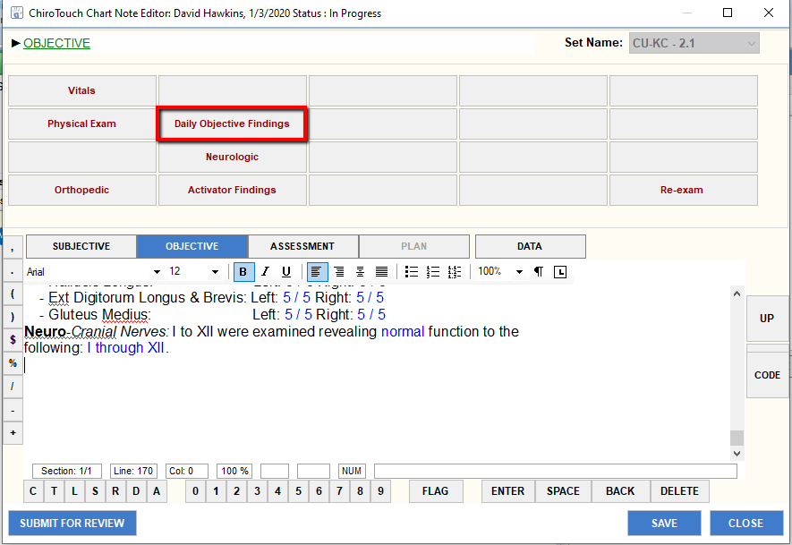

Click Daily Objective Tab – List of prompters appear.
Complete Active, Passive and Resisted ROM.
Freeform results into note.
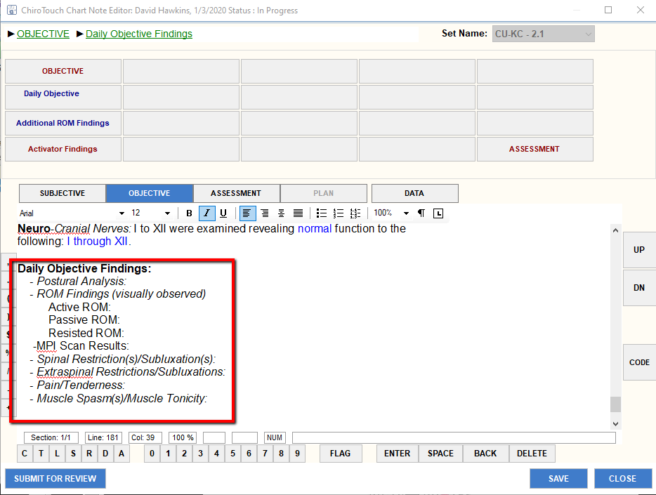

Click Objective Tab in breadcrumb at the top of the SOAP note to return to previous category screen.

Click Orthopedic Tab
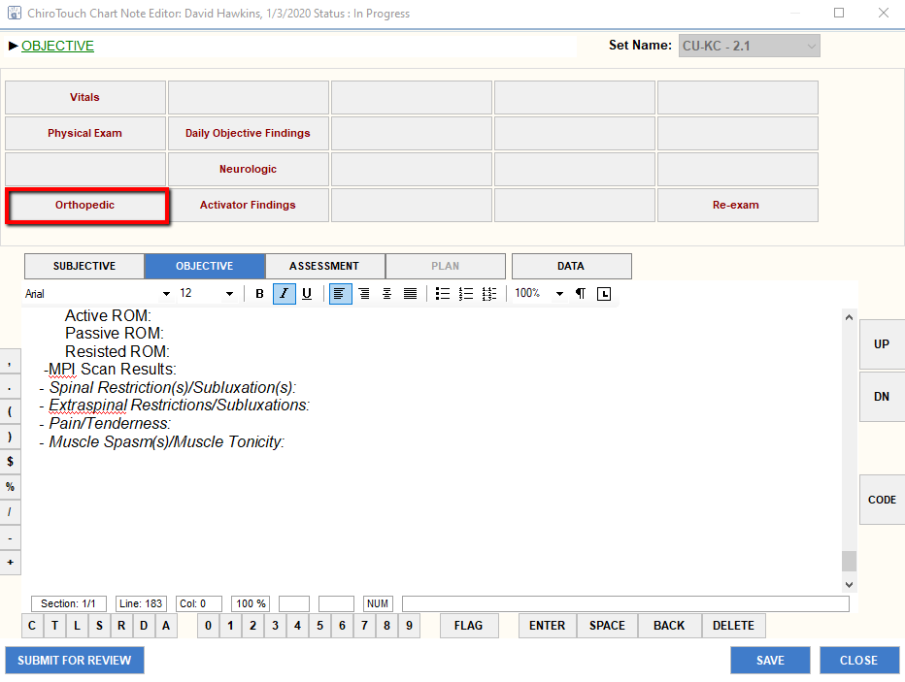

Then, click the appropriate Orthopedics region tab, based on patient complaint.
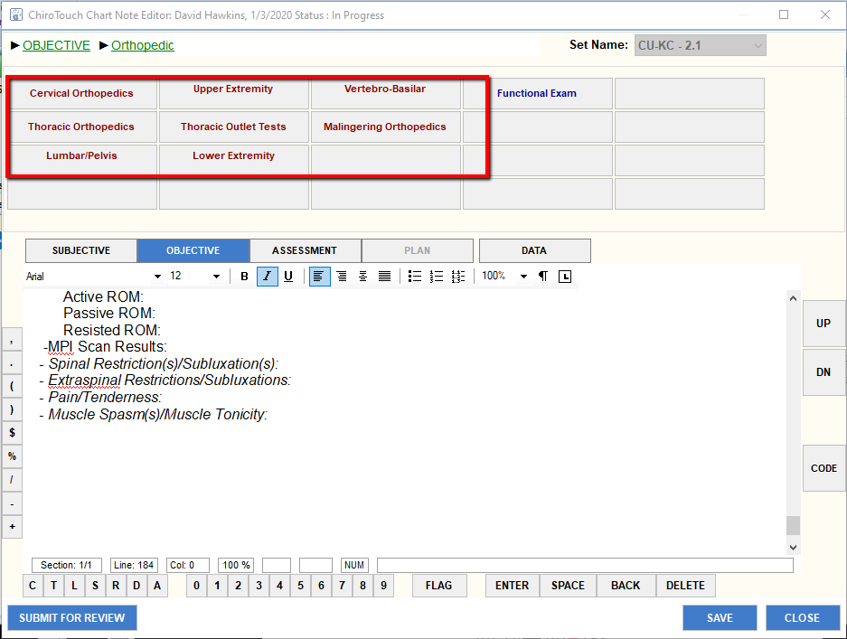

Example – In Cervical Orthopedics Tab:
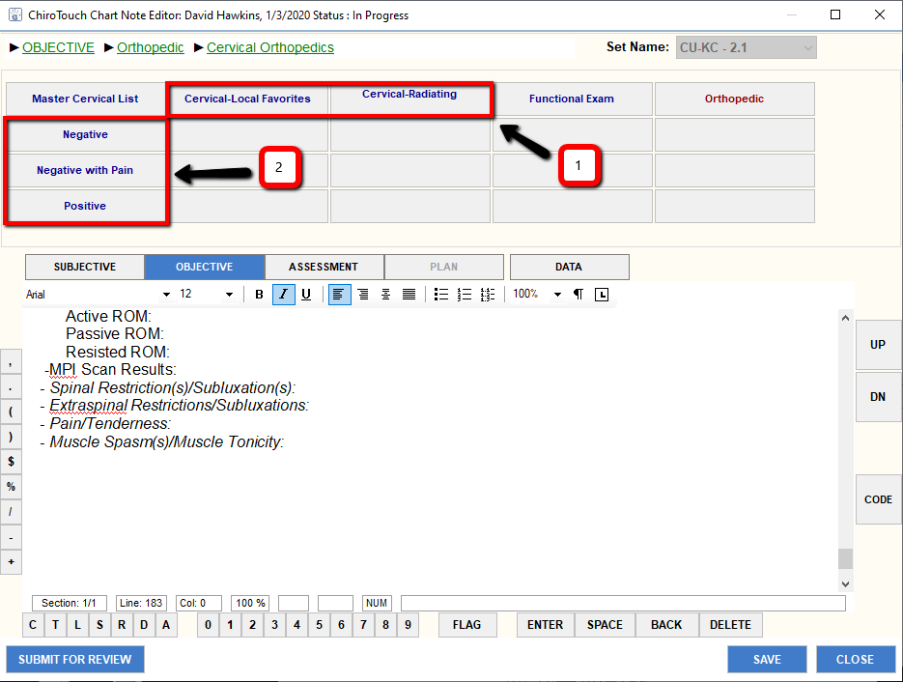
1. Select Cervical Local or Cervical Radiating tab based on patient complaint.
NOTE….
In order to link orthopedic test results with the specific test, select a single test, perform and record findings; then re-click Cervical Local or Cervical Radiating tab and click on the next test to perform.
a. This provides a list of Cervical Tests to be performed
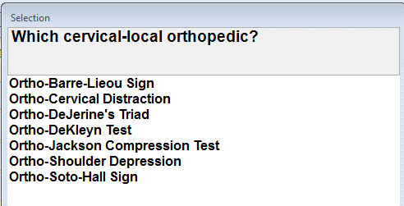

2. With completion of a Cervical Orthopedic test, use one of these tabs for the appropriate narrative to document the findings in the note.
Remember to localize and characterize all pain production and positive orthopedic tests.
a. Negative
b. Negative with Pain
c. Positive

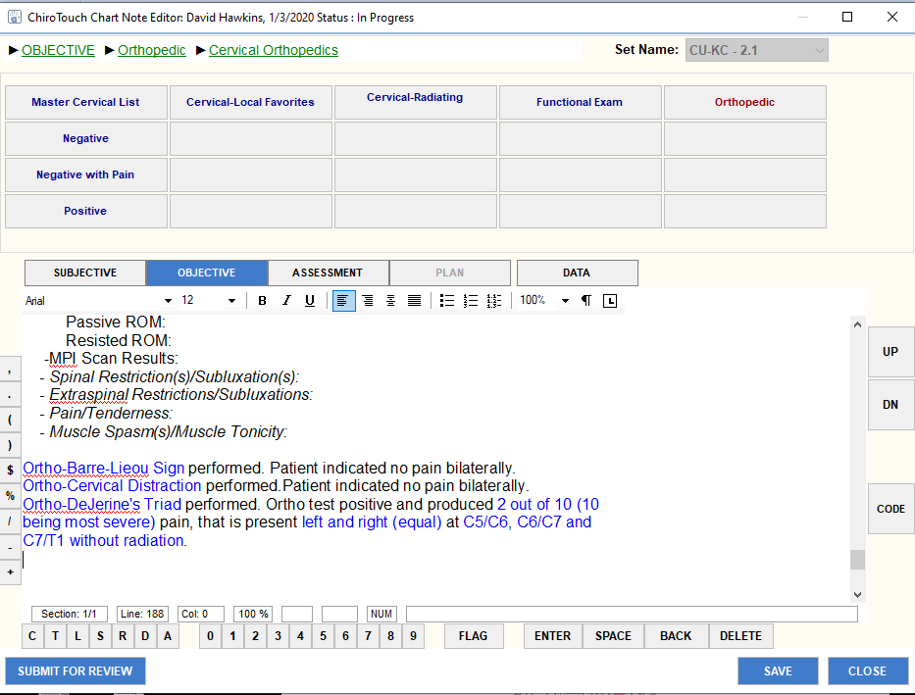

D. Assessment (A)

Two paths are available for the user to enter diagnoses and charges into the daily note. Path 1 is entering the codes through or within the Provider All-in-One (PAIO) and Path 2 is entering the code through the CODE tab located on the right side of the SOAP note in the Colleges Application.
Both paths allow the user to complete diagnoses and codes, which upload into the Assessment portion of the note. During completion of new patient examination and re-examination, access and input of diagnoses and charges thru the PAIO are more efficient since the user is required to open and complete/update the care plan through the PAIO as part of that day’s note. Using the CODE function in the SOAP note of the College Application streamlines the process during an established treatment care plan for daily visits by removing the need to open the PAIO since the approved diagnoses/charges are uploaded directly through the note.
As ChiroTouch continues adding further enhancements to the College Application portion of the program, a thorough understanding of these functions is necessary.

Click on Assessment tab
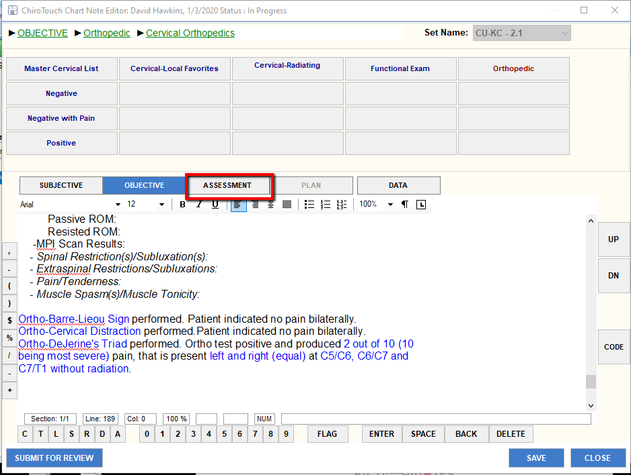

In order to have the patient’s diagnoses populate into the Assessment narrative and be available for the Primary Provider to review/approve, complete the diagnoses/procedures prior to completion of Assessment. Minimize the SOAP note – or – click Save tab (bottom right hand corner) to save the note then, click on the Provider All-In-One application to add Diagnoses/Charges... This is Path 1 Option

Complete billing for the day’s visit through the Provider All-in-One (PAIO) screen - (BILLING CANNOT BE COMPLETED THROUGH THE COLLEGE
APPLICATION)

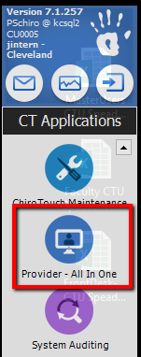
Open the CT Applications and click Provider All-in-One.

Provider All-in-One opens, click Sel:
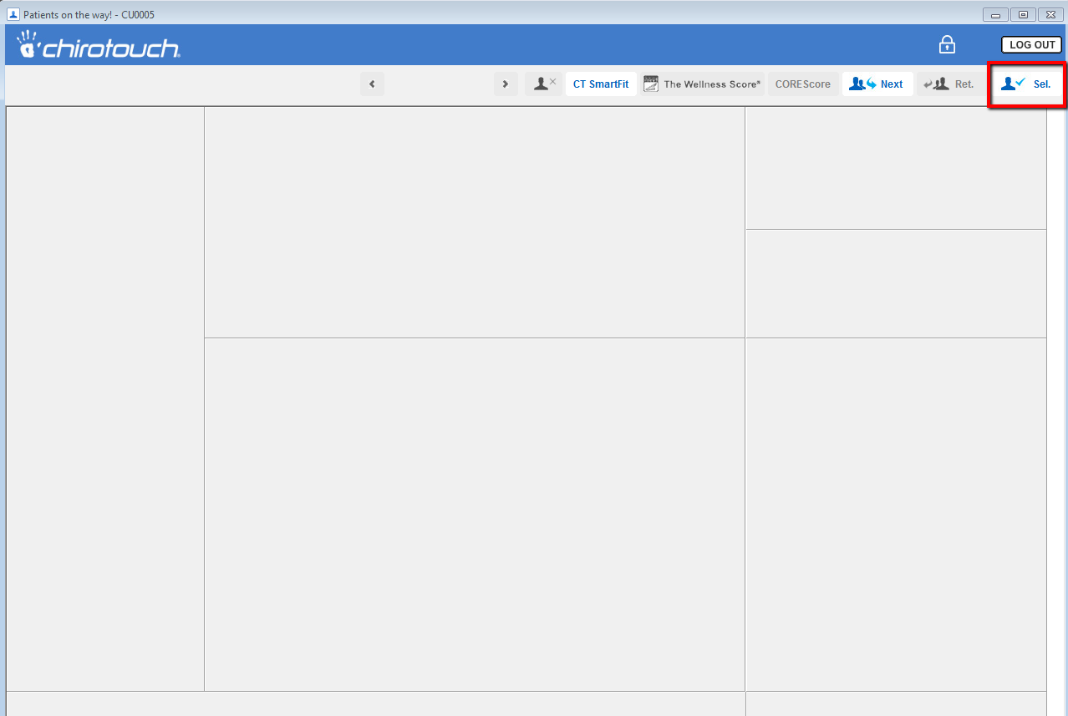

A pop-up window opens:

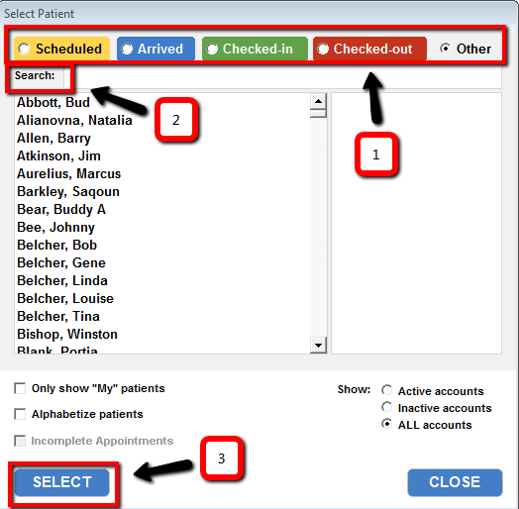
1. Click the button that reflects your patient’s status (scheduled today – choose Scheduled)
2. Type the first letter of the last name of the patient in the Search box, then scroll down to patient name and click to hi-light it.
3. Click Select

The patient’s PAIO populates:
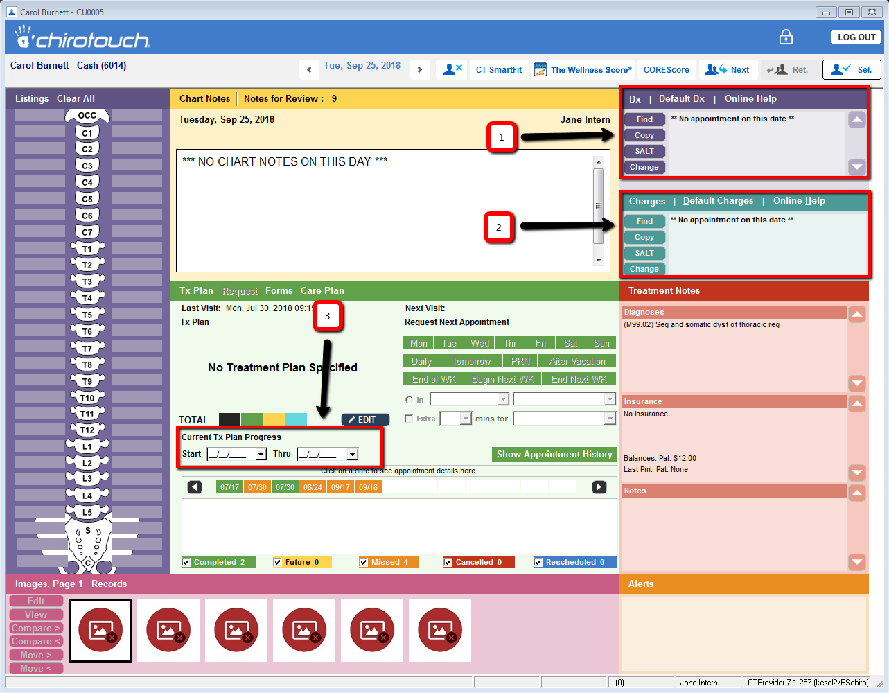
In order to bill for today’s visit, 3 items must be completed in the PAIO:
1. Diagnosis/Diagnoses (ICD-10 codes) entered.
2. Charge(s) (CPT codes) entered.
3. Current Tx Plan Progress entered for today’s exam/treatment.

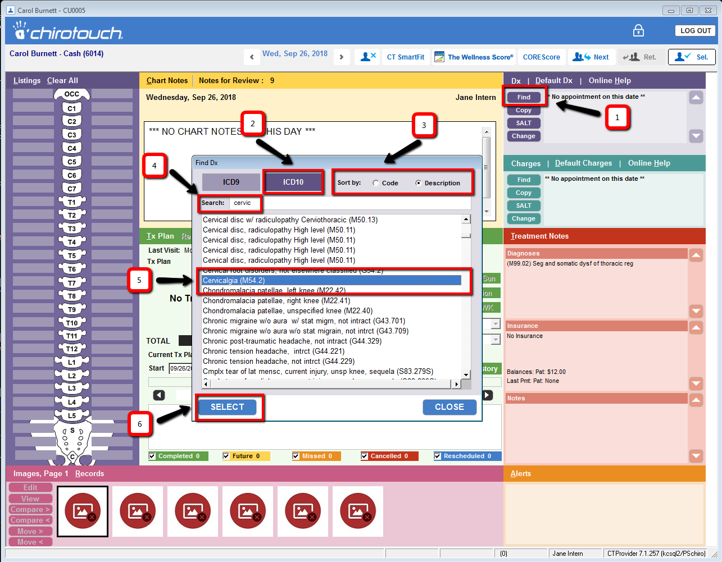

1. Click Find tab in the Dx box, which opens the Find Dx pop-up window
2. Click ICD10 tab
3. Click the Sort by format to use (Code or Description)
4. Click in search box – type numbers/letters to find diagnosis
5. Click on selection to hi-light
6. Click Select to add diagnosis to PAIO

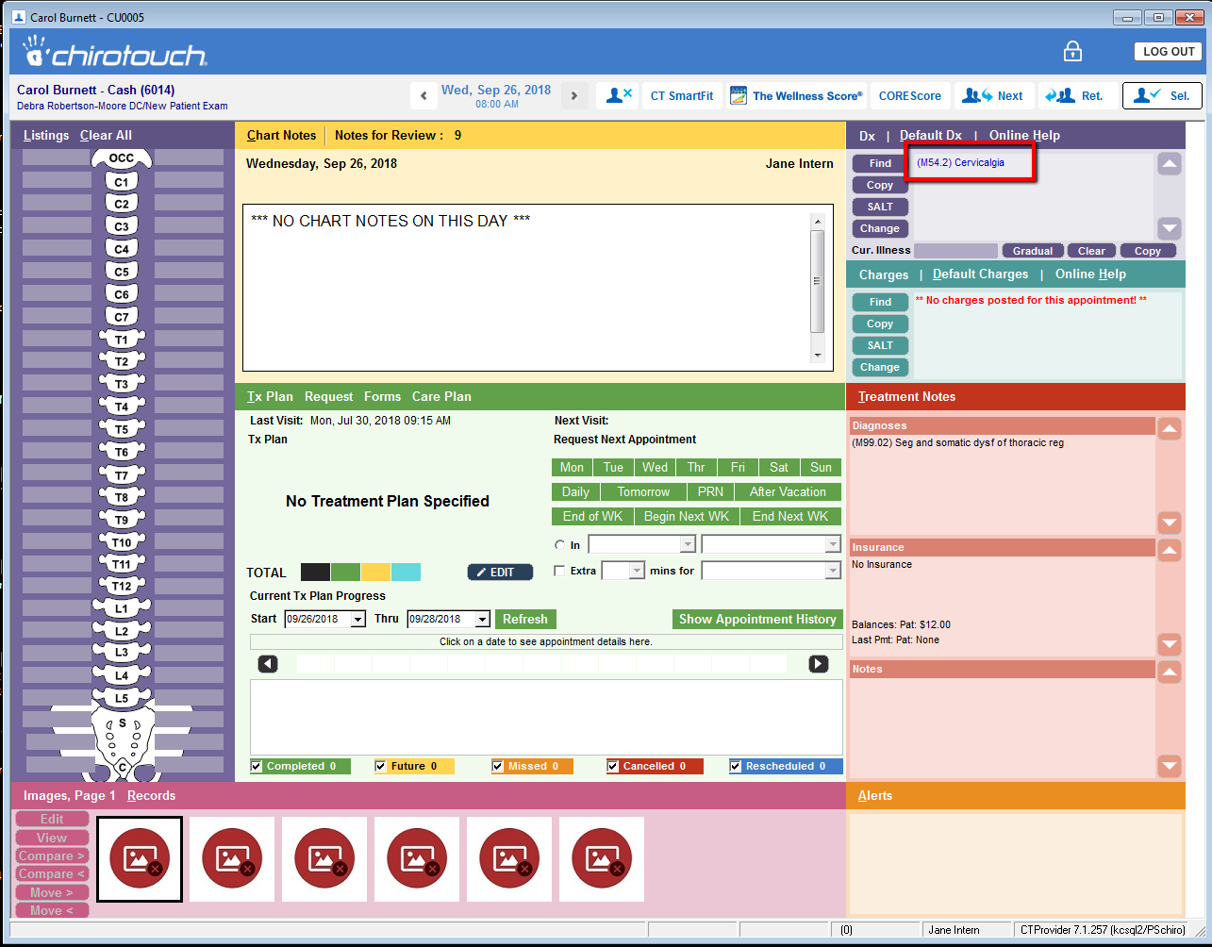
Selected ICD10 code is now in Dx box and is carried forward in subsequent notes, until it is updated.

Next, Charges for today’s procedures:
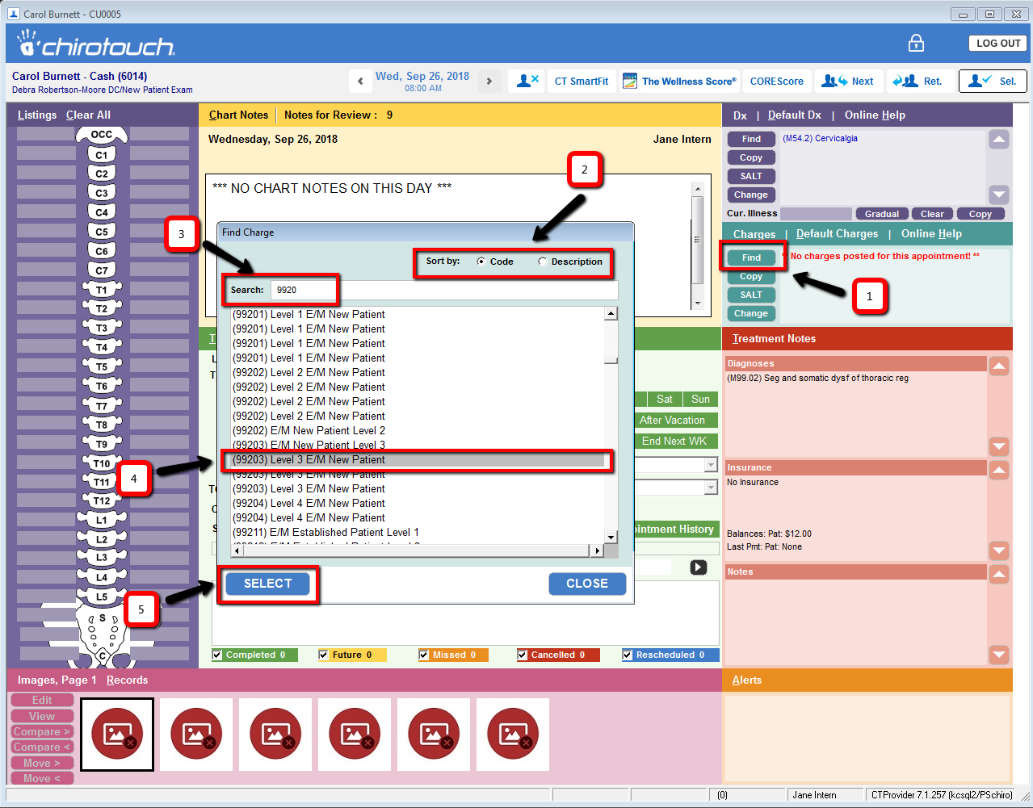
1. Click Find tab in the Charges box, which opens the Find Charge pop-up window
2. Click the Sort by format to use (Code or Description)
3. Click in search box then type numbers/letters to find diagnosis
4. Click on selection to hi-light
5. Click Select to add procedure to PAIO
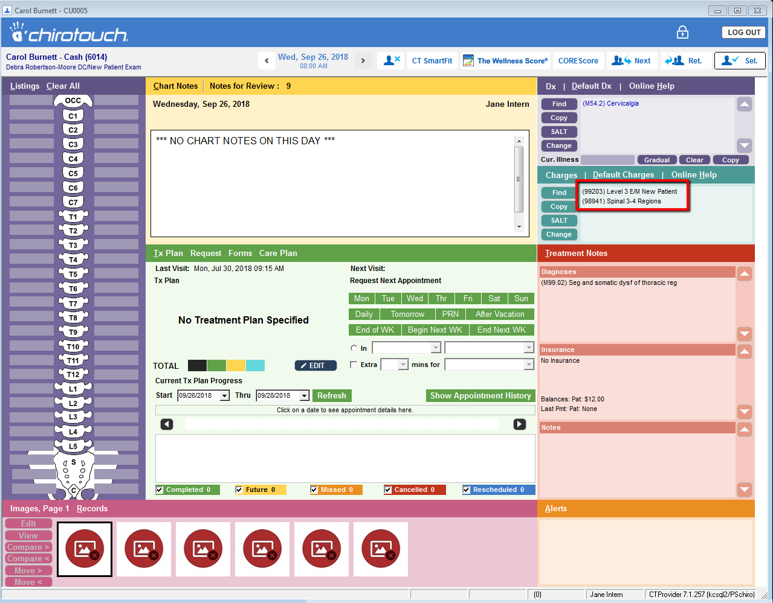
Selected procedure(s) is now in Dx box and is carried forward in subsequent notes, until it is updated.

With the addition of ICD-10 Codes/Charges, close the PAIO screen and move back to the Assessment portion of the SOAP in the College Application:

This is Path 2 Option:
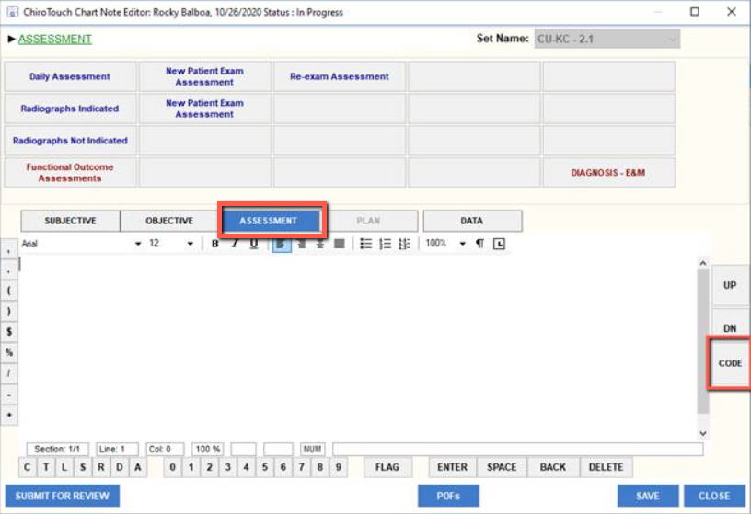
1. Click Assessment tab to open Assessment section.
2. Click CODE tab to open the Chart Note Coding window for selection of Billing and Charges codes.
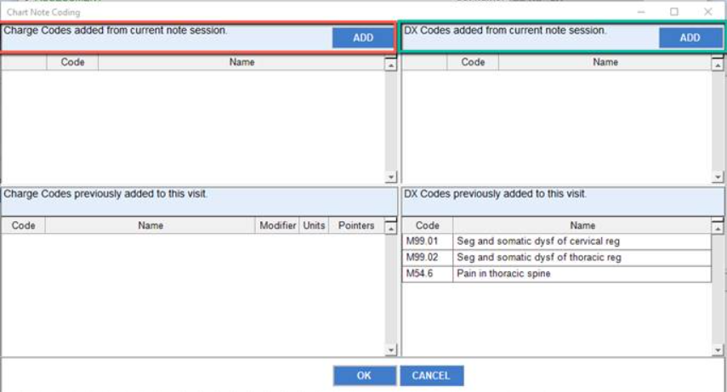
3. Click the ADD tab in the DX Codes box (green circled box) to open the available list of diagnosis
(ICD-10) codes to select from.
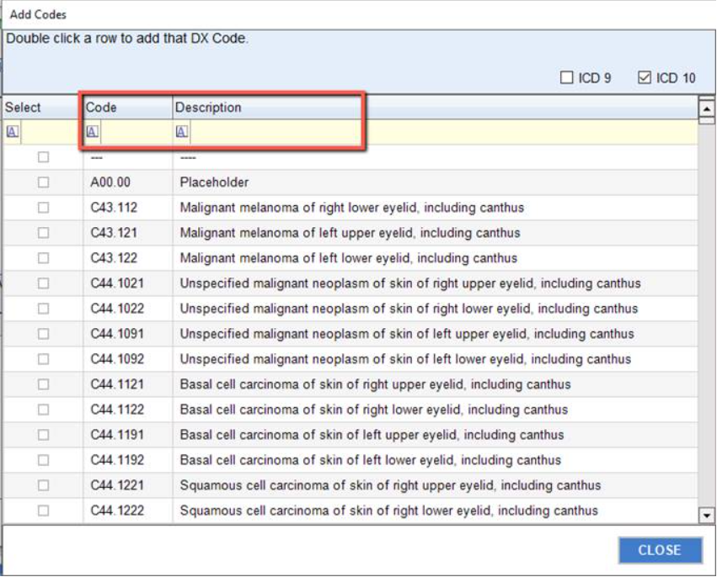
4. In the yellow box (circled in pink), enter the code number under Code or word description under
Description.
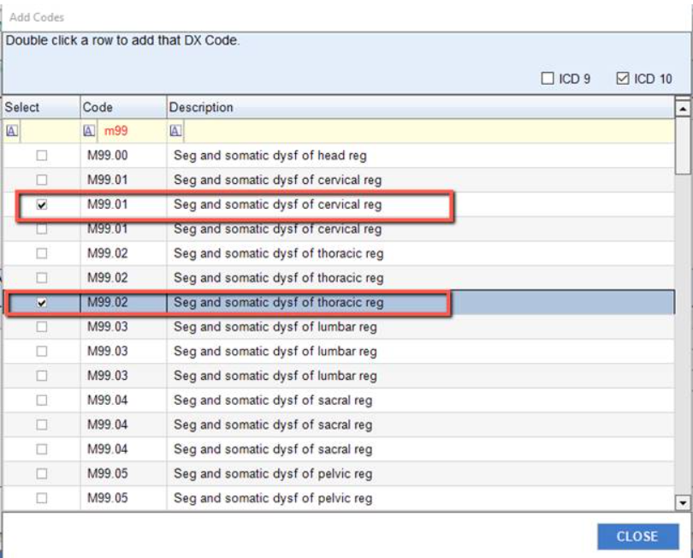
5. Locate the specific code and double click the line item (or click the box under the Select Column) to
add it to the Chart Note Coding Box. Multiple codes may be selected. Click CLOSE.

6. Click the ADD tab in the Charge Codes box to open the available list of Charge (CPT) codes to select,
then repeat steps 4 and 5. When finished, click CLOSE tab to exit the CODE window.

At the end of the New Patient Physical in Student Clinic, follow the procedure directly below this box.

Click New Patient Exam Assessment tab:
Complete prompter list by freeform.
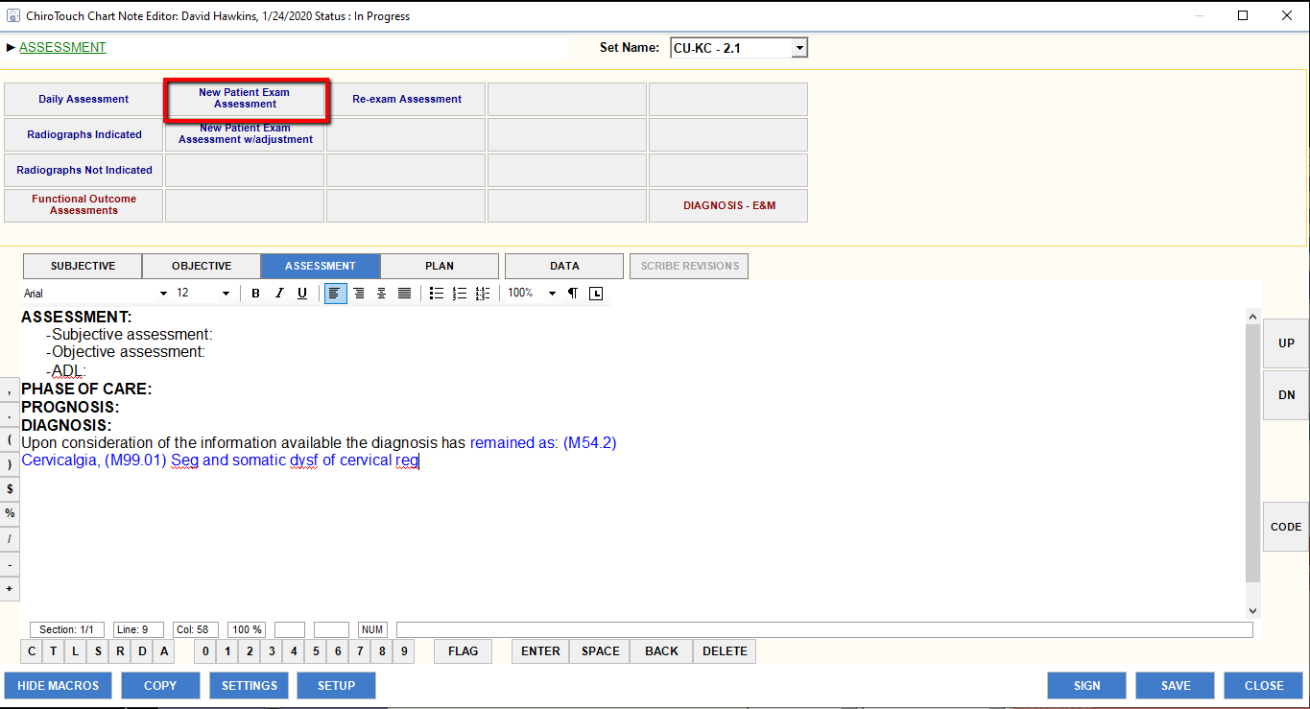

At the end of the New Patient Physical in Outpatient Clinic, if CMT (adjustment) is permitted, follow the procedure directly below this box.

Click New Patient Exam Assessment w/adjustment tab:
Complete prompter list by freeform.
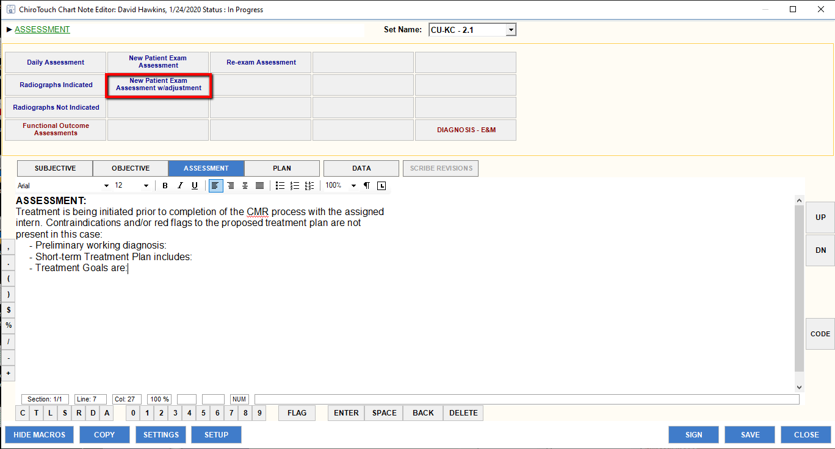

E. Submit for Clinician Review
Click Submit for Review tab to forward completed SOA portions to Primary Provider for review/approval.
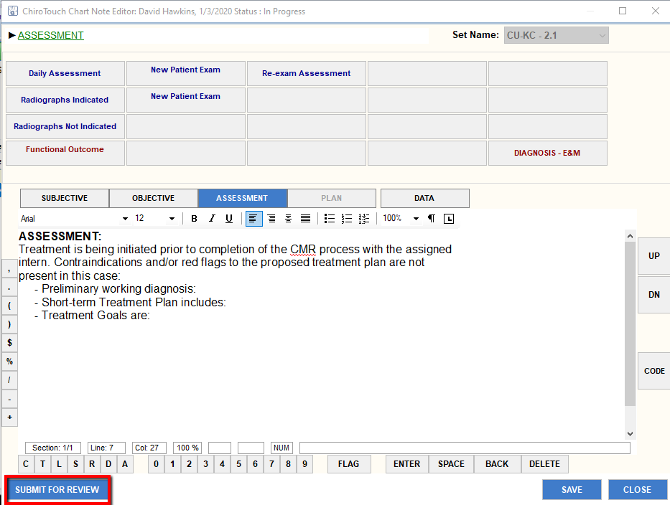

The submitted SOA portion shows up under the Note Revisions section of the College Application:
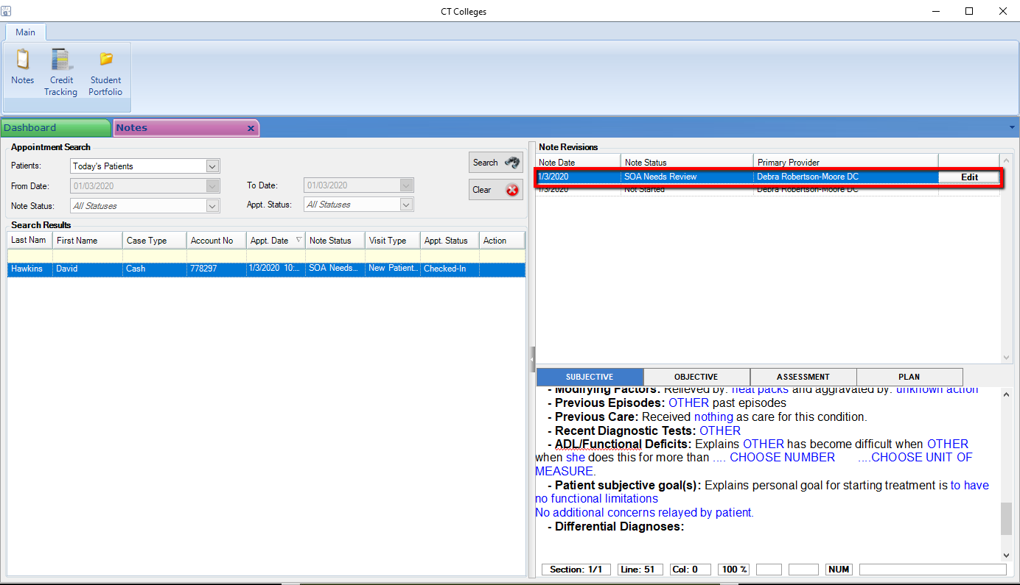

Primary Provider reviews the SOA portion, documents needed additions/changes in the bottom of the individual SOA sections.
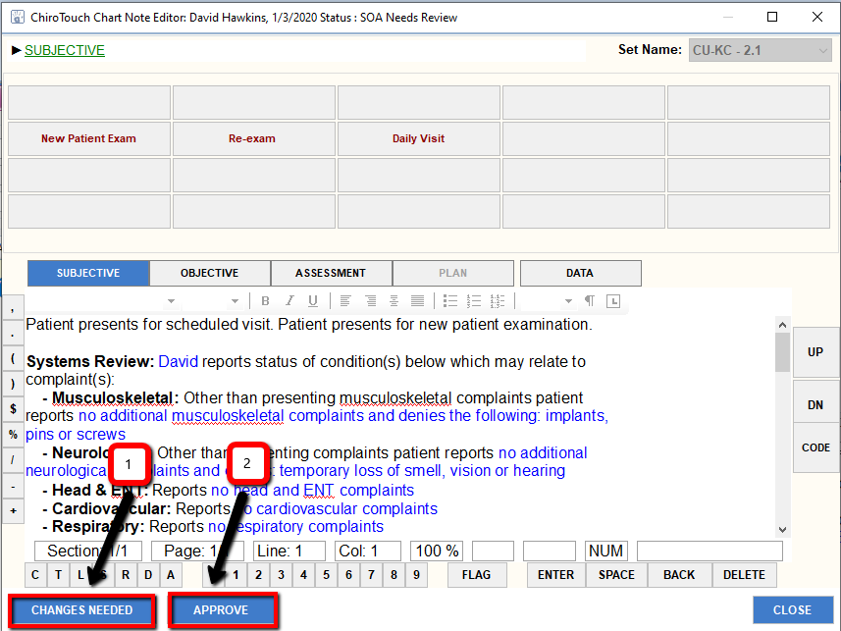
Click:
1. Changes Needed tab clicked when applicable
2. Approve tab clicked when applicable

A new window opens that requires the Primary Provider to enter their login information to complete the tab selected.

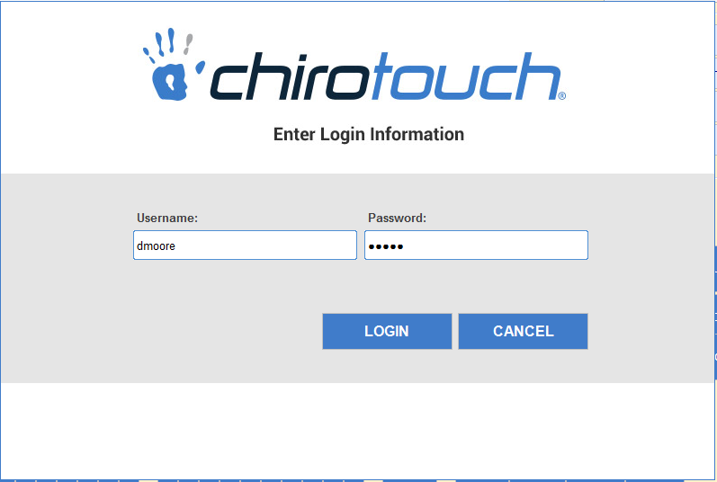

Login information closes and moves the user back to the College Application window:
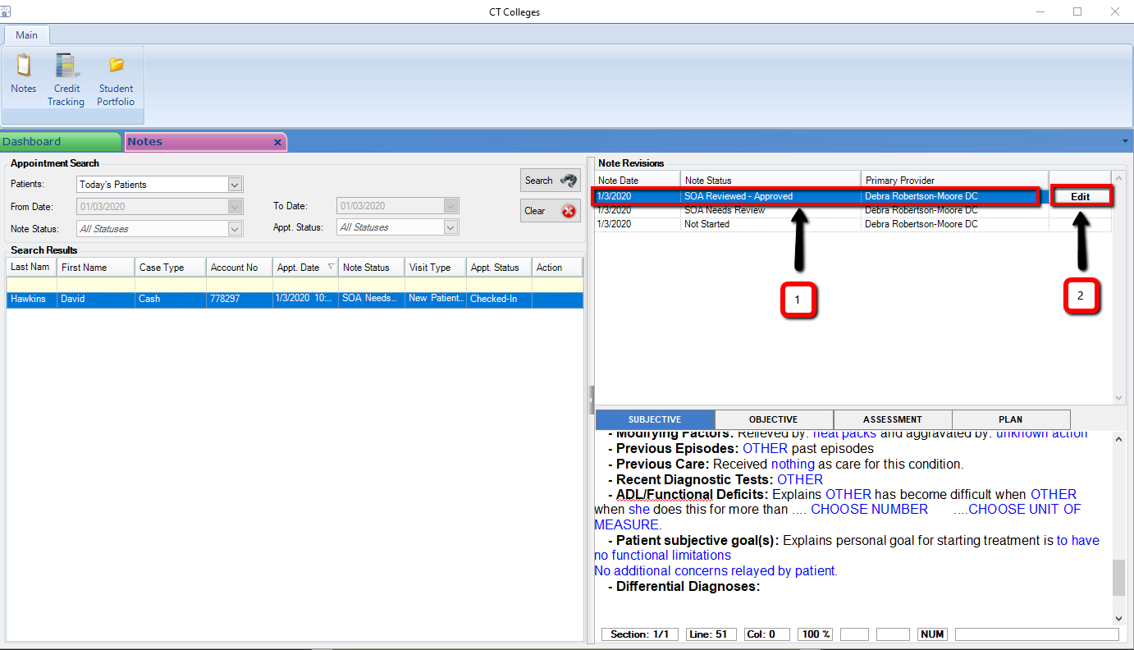
1. New entry under the Note Revisions section reflects the SOA approval
2. Intern click Edit tab to return to approved revision to review approval statement and proceed to P (Plan) portion.

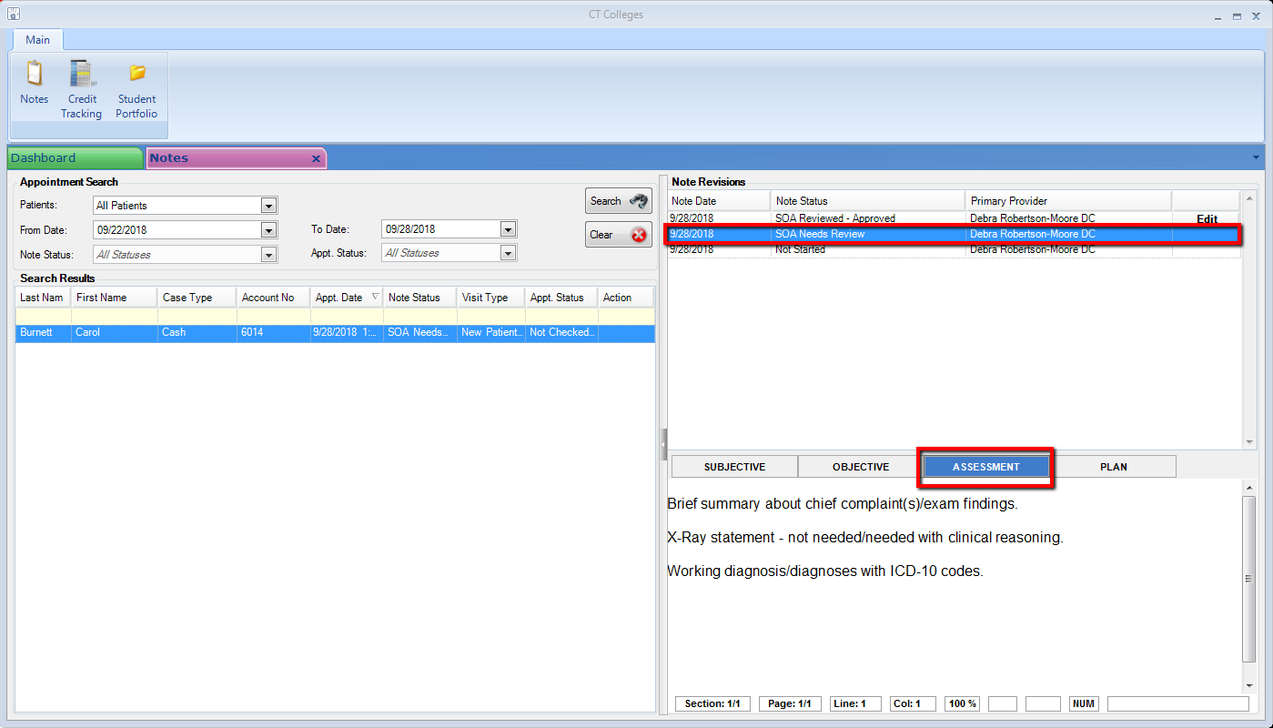
To access the approved Note Revision, move cursor to the approved line under Note Revision.

Note… In order to review all statements added to the note by the Primary Provider, the Secondary Provider (Student) must click on the line entry SOA Needs Review, move to the lower right corner of the window, click on the Subjective, Objective, Assessment tabs and review new documentation (if added by Primary Provider) at the bottom of each screen.
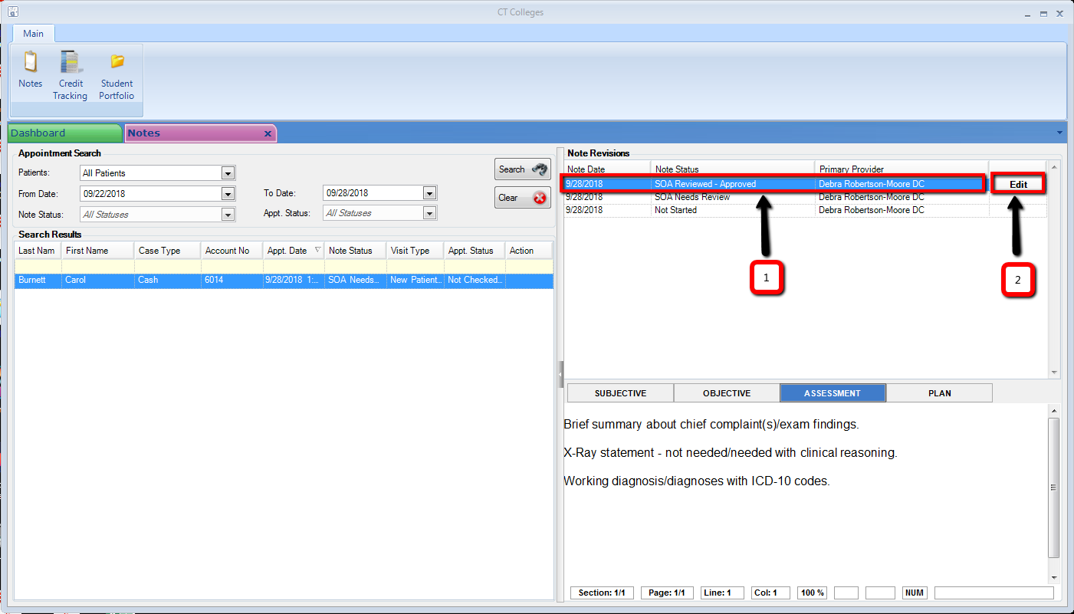
1. New entry under the Note Revisions section reflects the SOA approval
2. Intern click Edit tab to return to approved revision to review approval statement and proceed to P (Plan) portion.

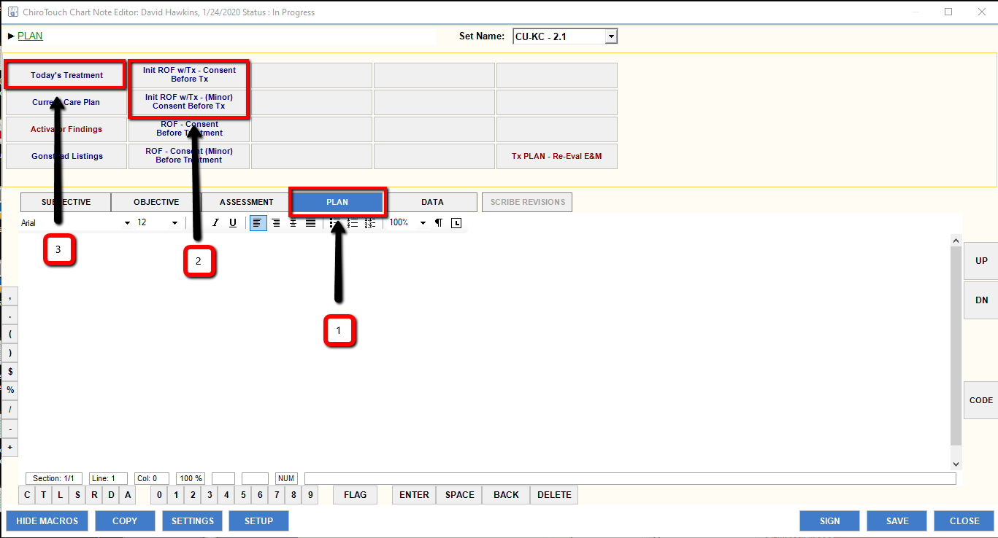
With CMT (adjustment) in Outpatient clinic:
Complete steps 1, 2 and 3.

In Student Clinic:
Complete steps 1 and 3.

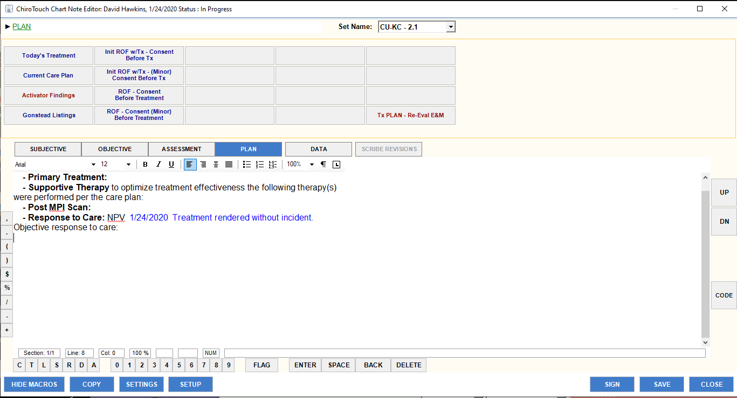

Update populated narrative or add freeform statement covering today’s treatment/procedure completed.

If Primary Provider has approved an adjustment with the examination, click ROF Init Visit tab:
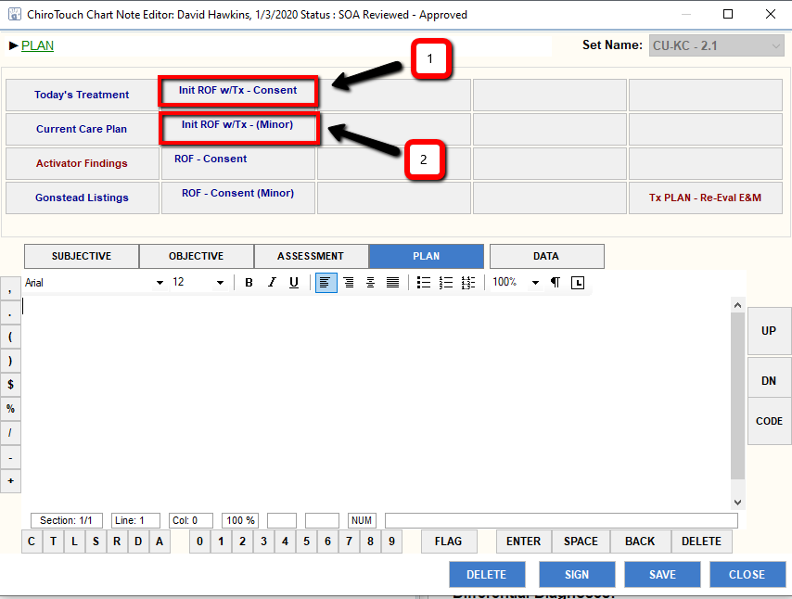
1. ROF Initial Visit w/Tx tab for adult.
2. ROF Initial Visit w/Tx tab for minor.

Select the appropriate ROF tab, click and correct statement as indicated.
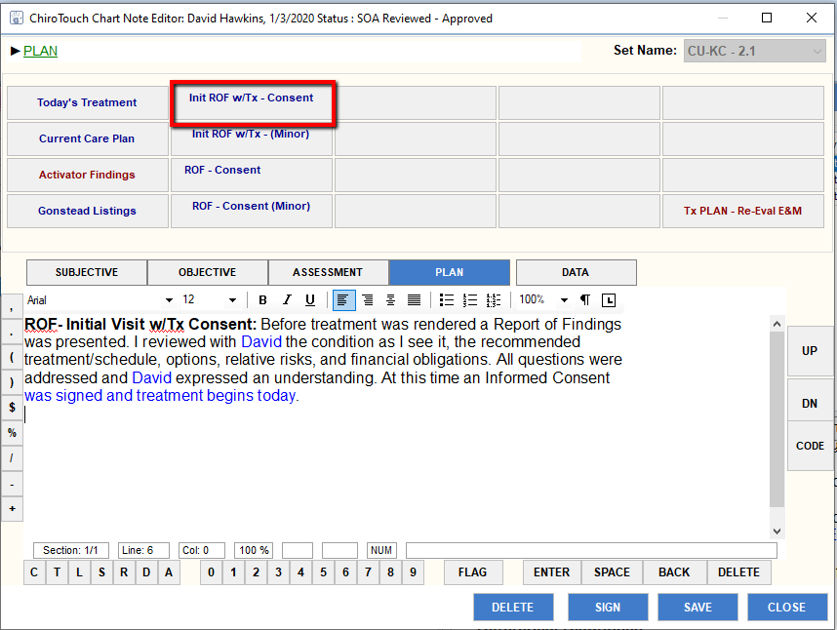

Click Today’s Treatment tab, complete each pop-up window and update narrative as needed:
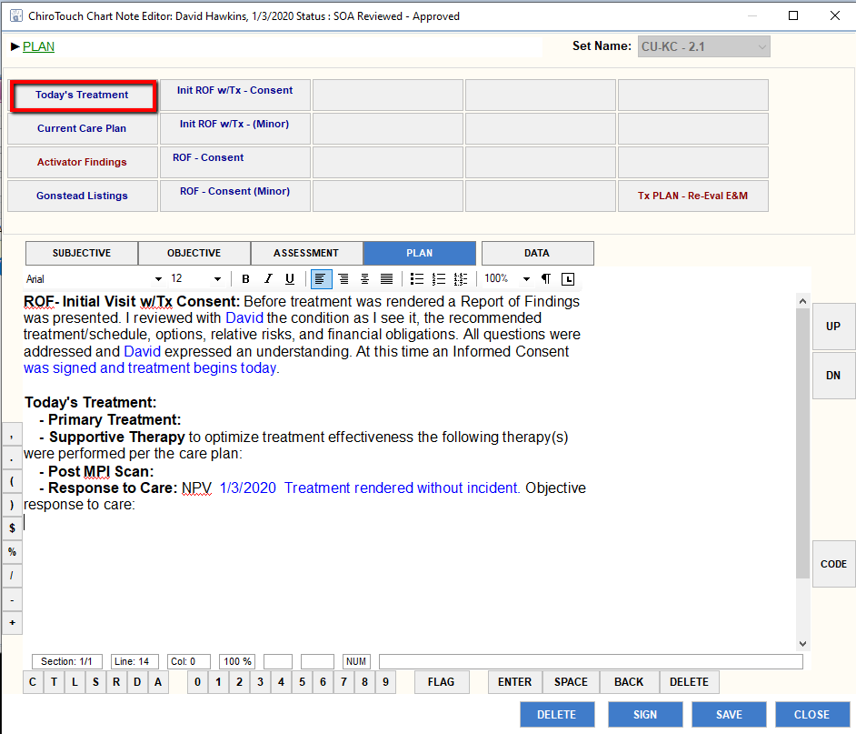

Primary Provider completes:
1. Primary Provider review P portion of the SOAP and the codes on the PAIO,
2. Verify correct codes are on the service slip, then sign service slip,
3. Click Save tab, to save the note.
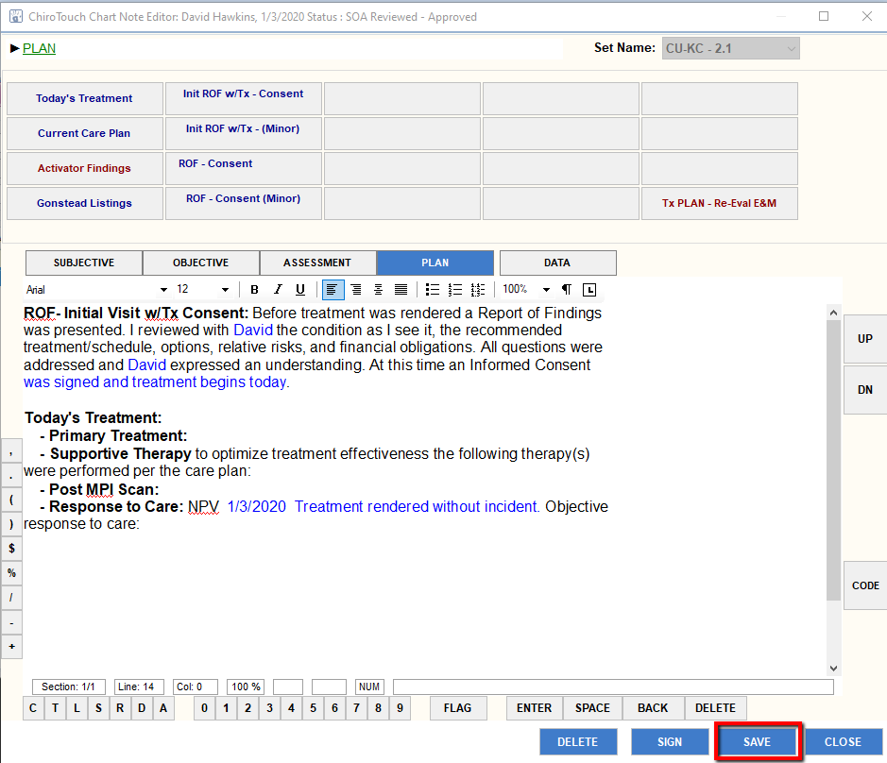
NEITHER Primary Provider or Secondary Provider sign (complete) the note.
-- Once the Secondary Provider signs the note, they can no longer access the note, if needed. And…
The note does not require completion for billing to push through to the front desk – requirements for billing are the patient is on the scheduler, checked in through the Front Desk and the appropriate ICD-10 codes/Charges listed in the PAIO.

